**Chapter I**

**Introduction**

A school website is a vital digital platform for educational institutions, serving as an information hub, communication center, and resource repository. It offers essential details about the school, academic information like course schedules and calendars, and facilitates seamless communication between students, parents, and staff through contact forms and directories. These websites keep the school community informed through news updates and enable convenient online registration and fee payments. They also act as a valuable resource hub, providing educational materials and fostering community engagement through blogs and forums. In essence, school websites play a pivotal role in enhancing transparency, communication, and efficiency within the educational ecosystem. (Tupas, 2015).

The current state of the LCCV website is one of concern, marked by notable deficiencies. The website exhibits outdated design elements, a discordant palette of colors and fonts, and a layout that lacks user-friendliness. Moreover, a substantial number of broken hyperlinks are evident, compromising the website's functionality and the accuracy of information it conveys to its audience. This suboptimal condition poses a potential risk to the school's reputation and undermines its capacity for effective online communication. To address these shortcomings and elevate the website's standing, a comprehensive redesign and modernization effort are imperative. This initiative will not only enhance user experience but also project a more favorable and professional image for the institution.

The forthcoming website will be a comprehensive and user-centric platform meticulously designed to fulfill the diverse needs of its stakeholders. It will effectively showcase vital information about LCCV as an institution, encompassing its mission, vision, and core values. This platform will provide real-time updates on the school's programs and events, promoting transparency and facilitating timely communication. Its intuitive and user-friendly interface will ensure accessibility for a broad audience, catering to students, parents, teachers, and the wider community. To enhance ease of navigation and information retrieval, the website will consist of distinct sections: "Home" for an institution overview, contact directory, and map; "About" for historical insights, mission, hymn, and facility details; "Announcements" for current and past notices along with the school calendar; "Admission" for program details, requirements, and a FAQs section; and "Contact Us" for school contact information, open hours, and a location map. This project aspires to bolster communication and engagement within the school community while effectively showcasing the institution's strengths and achievements to the broader public.

The forthcoming comprehensive website promises to deliver a range of significant and highly professional benefits to LCCV and its diverse set of stakeholders. Primarily, it will act as a potent tool to elevate the institution's esteemed reputation within the educational landscape. Through effectively communicating LCCV's mission, vision, and core values, the website is poised to attract prospective students and discerning parents who align with the institution's educational philosophy, thereby solidifying its enrollment figures and cementing its position as a trusted educational entity. Furthermore, the website will excel in refining communication channels, ensuring that all stakeholders, from employees and teachers to students and parents, can easily access critical information about school programs, events, and announcements. This will foster transparency, reduce the potential for misunderstandings, and facilitate the efficient dissemination of information in a thoroughly professional manner. Additionally, the website's capacity to streamline administrative processes will relieve the workload on employees, enabling them to focus more intently on their core responsibilities and fostering a more harmonious and productive work environment. Moreover, teachers will find the platform's ability to showcase their achievements and the institution's strengths highly beneficial, contributing to their professional recognition and growth. In summary, the comprehensive website promises to cultivate a more effective, cohesive, and thriving educational environment at LCCV, all conducted with the utmost professionalism.

**Conceptual Framework**

In the context of this research endeavor, it refers to a systematically structured framework crafted through the Input-Process-Output (IPO) method, aimed at guiding and underpinning the study. Its primary purpose is two-fold: firstly, to offer a clear and organized roadmap for the research, delineating its scope and boundaries, thus providing guidance for the research process. Secondly, it enhances clarity and comprehension by establishing coherent links between research questions and theoretical concepts. By employing the IPO method, the researcher ensures that the Input (research questions and objectives) is thoughtfully processed through various stages (literature review, data collection, analysis) resulting in valuable Output (research findings), thus strengthening the study's overall structure and contributing to the rigor and depth of the academic inquiry.

OUTPUT

PROCESS

INPUT

**HARDWARE**

Computer Desktop, Laptop

**SOFTWARE**

HTML, CSS, JavaScript, Visual Studio Code, Photoshop

**KNOWLEDGE**

Web Development & Designing  
  
School’s information and Operation

**NETWORK**

Internet Connection

**Development of Accessible and Inclusive LCCV Website: A Platform for Communication between the Institution and their Clientele.**

**Waterfall Life Cycle Model**

Define the project scope and requirements.

Gather and document requirements.

Develop a detailed and informative design.

Perform testing.

Deploy the website.

Evaluate the website's effectiveness.

**LCCV WEBSITE**

Figure 1. *Conceptual Framework*

In the input section it encompasses critical foundational elements. "HARDWARE," represented by computer desktops and laptops, serves as the essential workstations for coding and design tasks. "SOFTWARE" includes HTML, CSS, JavaScript, Visual Studio Code, and Photoshop, which are fundamental tools for web development and design. "KNOWLEDGE" incorporates expertise in web development, design, and an understanding of school's information and operations, guiding decision-making throughout the project. Lastly, "NETWORK" highlights the necessity of an internet connection for online resources, real-time testing, and potential website hosting. Collectively, these inputs lay the groundwork for a successful website development project tailored to school's unique needs and objectives.

The Waterfall Software Development Life Cycle (SDLC) model is a structured and linear approach to software development that follows a sequential progression of phases, each building upon the preceding one. Its primary purpose is to provide a systematic framework for developing software by starting with rigorous planning and documentation, moving through design, coding, testing, deployment, and concluding with maintenance and support. This model is particularly suitable for projects with well-defined, stable requirements and is often used in industries with strict regulatory compliance needs. However, it may not be well-suited for projects where requirements are subject to frequent changes or in rapidly evolving environments, as it lacks the flexibility and adaptability of more agile development methodologies.

**Waterfall (SDLC) Model:**

1. Planning phase:

Define the project scope and requirements: This includes determining the purpose of the website, the target audience, and the key features and functionalities needed.

2. Analysis phase:

Gather and document requirements: This includes defining the features and functionalities of the website and creating a detailed requirements document.

In these two phases, the developer engages in thorough discussions with stakeholders and capstone adviser to gather and document detailed requirements. Interviews, surveys, and research to understand project objectives, scope, and constraints is conducted to create a comprehensive requirements document outlining the project's specifications.

3. Design phase:

Develop a detailed and informative design: This includes creating wireframes, mockups, and prototypes to illustrate the website's design and functionality.

During this phase, the architectural and high-level design plans are created based on the gathered requirements. Steps involve defining system components and their relationships, often using tools like flowcharts and diagrams. The developer also develops detailed design documentation that serves as a blueprint for implementation.

4. Development phase:

Perform testing: This includes unit testing, integration testing, and user acceptance testing to ensure that the website meets the requirements and functions correctly.

This phase entails actual coding and development, where programmers write the code following design specifications. Actual steps include coding individual modules, ensuring coding standards are met, and performing code reviews to maintain code quality and consistency.

5. Implementation phase:

Deploy the website: This involves making the website available to the public and ensuring that it is accessible on different browsers and devices.

Deployment involves the installation of the software in a production environment. Actual steps include configuring servers, databases, and other infrastructure components as necessary for the software to run effectively. Deployment procedures are followed to ensure a smooth transition from development to live production.

6. Operation and Maintenance Phase:

Evaluate the website's effectiveness: This includes evaluating the website's performance based on key metrics and making data-driven decisions to improve its effectiveness.

Once the software is live, ongoing maintenance activities include monitoring, addressing issues, and providing updates based on user feedback. Actual steps encompass regular system monitoring, bug tracking, applying patches and updates, and continuously improving the software to meet changing user needs.

**Theoretical Framework**

A structured collection of principles and concepts is utilized to inform and guide research, offering a fundamental basis for comprehending a phenomenon. It benefits researchers by offering a lens through which to examine and interpret data, enabling hypothesis development, and fostering consistency and coherence in research design. The framework also allows for the connection and comparison of findings across studies, thereby contributing to the development of new knowledge. Moreover, it helps researchers in identifying gaps and potential contributions to existing theories, thus inspiring future research.

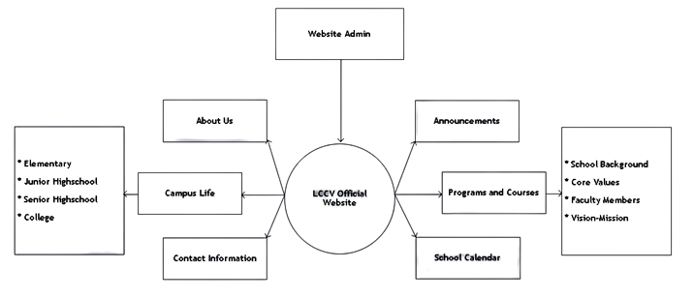

Figure 2. *Theoretical Framework*

Figure 2 depicts the various elements involved in the theoretical framework that the researcher intends to incorporate. The boxes outline the different sections of the school website, including subtopics related to the main topic.

The researcher, acting as the Website Admin, will have primary access to the website's internal system. The website will serve as a platform for disseminating information to a broader audience publicly.

**Statement of the Problem**

The problem that this project aims to address is the lack of a comprehensive and user-friendly website for LCCV. This has prevented effective communication and engagement with the school community and the wider public. The current website, if it exists, is outdated, difficult to navigate, and does not provide the necessary information for users. As a result, users have had a poor experience with the website, which may have contributed to decreased engagement with the school community and potentially affected enrollment rates and the overall reputation of the school. The project aims to design and develop a modern and functional website for LCCV that will enhance communication, engagement, and overall user satisfaction. The website will serve as a centralized platform that provides comprehensive information about the school. The website will also showcase the school's strengths and achievements to a wider public, raising its profile and improving its reputation.

Specifically, this research aims to answer the following problems:

**Problem Questions**

1. What are the current challenges faced by schools in creating a user-friendly and responsive website that caters to the needs of all its users?
2. How can the researcher overcome the lack of technical expertise in creating and maintaining a website that is regularly updated and informative?
3. What are the most effective strategies that schools can adopt to market and promote their website to ensure maximum reach and engagement among all its stakeholders?
4. What are the potential benefits that a well-designed and maintained website can bring to a school, including improved communication, better engagement, and enhanced learning outcomes for students?
5. How can schools evaluate the effectiveness of their website in addressing the needs of all its users and meeting its goals and objectives?

**Scope and Limitation**

The school website project for La Consolacion College Valenzuela (LCCV) includes the creation of an informative and user-friendly online platform. The website will feature a "Home" section offering a concise introduction to LCCV, including its mission and vision, along with a convenient "Contact Us" directory and an interactive map for easy navigation to the campus. The "About" section will provide detailed information about LCCV, including its rich history, academic programs, school facilities, the school hymn, and information about other campuses if applicable. The "Announcement" section will keep users updated with current and archived important announcements, as well as a school calendar. The "Admission" section will guide prospective students through various academic programs offered by LCCV, including requirements and a FAQs section for clarification. Lastly, the "Contact Us" section will offer essential contact information, including phone numbers, email addresses, office hours, and a map for directions to the LCCV campus.

Despite its comprehensive features, the project's limitations include the absence of certain functionalities commonly found in educational portals. Specifically, the website will not support the enrollment process, and there will be no provision for uploading or accessing educational modules. Additionally, dedicated student and teacher portals, which often provide specific interactions and functionalities within educational institutions, will not be included in this initial website implementation. These limitations help define the project's boundaries and clarify which features and functionalities will not be part of the initial website development.

**Significance of the Study**

The primary objectives for developing an accessible and inclusive website for LCCV include enhancing communication, information dissemination, and overall interaction among students, parents, school administrators, faculty members, and the school institution. The beneficiaries on this research are the following:

***School Institution:*** The website significantly enhances the school's online presence, making it more accessible to a broader audience. This increased visibility can attract more students and parents to the institution, potentially resulting in higher enrollment rates and strengthening the school's reputation as a reputable educational institution within the community and beyond.

***Students:*** The website empowers current students by providing them with a central platform to access critical information about their education. They can make informed decisions about courses, extracurricular activities, and events, contributing to their overall academic success and personal development. The website ensures they stay updated on essential announcements and events throughout the school year, fostering a sense of engagement and participation in school life.

***Future Students:*** Prospective students benefit from the comprehensive information available on the website. It acts as a valuable resource for them to explore the school's academic programs, campus culture, and offerings. By accessing this information, they can make informed decisions about whether the institution aligns with their educational goals and aspirations. This, in turn, may lead to increased enrollment, benefiting both the school and the prospective students.

***Parents:*** Parents can access essential details about the school's academic programs, campus culture, and important events through the website. This central information hub equips parents with the knowledge they need to actively support their children's education. They can make well-informed decisions regarding their children's participation in academic and extracurricular activities, ultimately contributing to their educational journey.

***Faculty Members:*** The website serves as a platform for faculty members to showcase their expertise and contributions to the school. This recognition fosters a sense of pride and motivation among educators, potentially leading to higher job satisfaction and a more dedicated teaching staff. Prospective students and parents can also identify key faculty members, enhancing their understanding of the school's academic offerings.

***School Administrators:*** School administrators benefit from the website as it provides a streamlined platform for disseminating critical information and announcements to the school community. This improves communication between the school and its stakeholders, reducing reliance on traditional, paper-based methods. The efficiency of information sharing enhances administrative processes and overall school management.

***Future Researchers:*** The capstone project serves as a valuable source for future researchers interested in web development and educational technology. It offers insights into methodology, design principles, and findings that can inform future research in the field. Researchers examining the effects of similar platforms on various educational stakeholders can find the project's content and outcomes extremely insightful and informative for their own studies.

**Definition of Terms**

In order to understand some unfamiliar terms, the following terms were defined through operational definition.

***Accessibility.*** Accessibility refers to the ease with which individuals can access and use something, such as a website, regardless of their physical or technological limitations.

***Centralized platform.*** A centralized platform refers to a unified or consolidated system where various information, services, or functions are brought together in one place. In the context of a school website, it means that users can access a wide range of resources or features from a single location.

***Comprehensive.*** Comprehensive means thorough, inclusive, and covering all relevant aspects or elements. In the context of a school website, a comprehensive platform would provide a wide range of information and services to cater to the needs of different users.

***Connectivity.*** Connectivity refers to the state of being connected or linked, especially in terms of internet access and communication between individuals or devices.

***Engagement.*** Engagement in the context of a website refers to the level of involvement, interaction, and interest that users have with the content and features provided by the website.

***FAQ's.*** FAQ's stands for Frequently Asked Questions, which is a section on a website that provides answers to common queries or concerns users may have.

***Navigability.*** Navigability refers to the ease with which users can navigate or move around a website to find the desired information or perform specific tasks. It relates to the organization, clarity, and intuitiveness of the website's structure and menus.

***Outdated.*** Outdated refers to something that is no longer current, up-to-date, or relevant in comparison to the prevailing standards or advancements. In the context of a website, an outdated design or content may lack modern features or fail to meet current user expectations.

***Profile.*** Profile refers to the public image, reputation, or representation of a school or any other entity, particularly in terms of how it is perceived by others.

***Transparency.*** Transparency refers to the quality of being open, honest, and clear in providing information and communicating with users, fostering trust and credibility.

***User.*** In the context of a website, a user refers to an individual who interacts with the website to access information, engage with features, or perform specific actions.

***User engagement.*** User engagement refers to the level of active participation, involvement, or interaction that users have with a website or digital platform. It can include actions such as commenting, sharing, or contributing content.

***User experience.*** User experience (UX) refers to the overall experience and satisfaction a user has while interacting with a website or other digital products, including factors such as usability, design, and functionality.

***User satisfaction.*** User satisfaction refers to the level of contentment or fulfillment experienced by users when interacting with a website or digital product, indicating the success of meeting their needs and expectations.

***User-friendly interface.*** A user-friendly interface refers to a website's design and layout that is easy to navigate, understand, and use, even for individuals with limited technical skills or familiarity with the platform.

***Well-designed.*** Well-designed refers to a website that has been thoughtfully planned, organized, and visually appealing, with a focus on providing a positive and intuitive user experience.

**Chapter II**

**Review of Related Literature**

This serves to comprehensively synthesize existing scholarly work relevant to the research topic, establishing its broader context, identifying research gaps, and providing a theoretical foundation. This critical analysis of prior research informs the selection of research methodologies and supports the formulation of hypotheses or research questions, ensuring that the new study contributes meaningfully to the existing body of knowledge.

**Foreign Literature**

Star Web Article (2021). Organizations in the education industry need to have responsive education websites since they are often the first point of contact for students and parents. Thus, a custom web design website can improve the overall image and reputation of your organization, which can increase admissions. In addition to helping your educational organization establish itself, a website is also vital. These days, students and parents expect organizations to have a web presence. An updated, informative, and well-designed website will help your organization gain credibility. Educational organizations can easily increase interaction with students and their parents through custom web design website.

Vijayan, A. (2023). The website of an educational institution serves as the primary point of contact for students and their parents. Online research is typically conducted to gather information about the institution, making the website crucial for creating a first impression. It is important to remember that the first impression is often the most significant. Although some educational institution owners believe that there is no difference between a low-quality and high-quality website, the reality is that a low-quality website can create a negative impression, while a premium quality website can make a positive impact from the very beginning.

Star Web Article (2021). Your website and social media platforms may be your sole tools for building brand awareness. The significance of brand awareness stems from its crucial role in the initial step of the marketing funnel and as a foundational element that ultimately leads to audience acquisition. A memorable and recognizable brand can be established through brand awareness. In turn, brand awareness helps maintain top-of-mind awareness with your target audience. Familiarity and comfort with your organization can be fostered through brand awareness. By utilizing a website, you can effectively reach and engage with your target audience.

School Jetter (2023). The school website serves as a crucial tool for creating a positive first impression, as it is often the initial point of contact for individuals with the school. The website’s quality can have a significant impact on the school’s overall image and reputation, potentially resulting in increased admissions. Additionally, having a well-designed school website is essential for providing an optimal user experience for regular users, including teachers, students, and parents.

Bennett, C. (2019). The school website serves as a crucial tool for creating a positive first impression and virtual visit for parents and students before physically entering the school building. The information available on the website can highlight the school’s best qualities and convey the school community’s welcoming nature to all stakeholders, including parents, students, educators, and community members. After creating a positive first impression, the website can provide a wealth of information, from posting exam schedules to announcing early dismissals due to inclement weather. Additionally, the website can effectively communicate the school’s vision, mission, qualities, and offerings to all stakeholders. Ultimately, the school website presents the school’s personality to its visitors.

**Local Literature**

OECD (2019) The increasing reliance on online platforms in our personal and professional lives has become a significant part of our daily routines. These platforms have become essential for various activities such as buying and selling goods and services, seeking information, and maintaining communication with others. They serve as sources of entertainment, news, transportation, accommodation, job searching, app discovery, and more. However, the complexity of online platforms often leads to important policy questions and a lack of comprehensive understanding. This report offers detailed profiles of twelve prominent global platform companies, aiming to provide insights into their operations, strategies, and financial success. The report highlights that while platforms share certain economic characteristics, they exhibit such diversity that they cannot be easily categorized into a few groups or a single sector.

ChildHopePH (2021) The Department of Education (DepEd) in the Philippines has implemented distance learning methods to ensure uninterrupted education by incorporating technology and internet connectivity. This approach enables students to pursue their education remotely through a range of online/offline platforms, television and radio broadcasts, and printed learning materials. These resources can be accessed through different methods, including blended learning, where multiple modalities are combined to optimize learning outcomes, and home schooling, where students receive instruction from a caregiver acting as their teacher.

Painagan, M.F. (2023) Digital marketing techniques have revolutionized the way small businesses can expand their reach and connect with customers, providing a cost-effective and scalable solution to engage with a global audience. In the context of growing businesses in the Philippines, online marketing offers several advantages such as precise audience engagement, transcending geographical boundaries, personalized targeting, continuous communication throughout the purchase process, cost-efficiency, and the ability to track and monitor marketing campaigns effectively. By leveraging digital marketing strategies, businesses can effectively reach a larger customer base, tailor their offerings, build brand loyalty, and drive growth in the dynamic online landscape.

Puripong, K. (2021). One of the most popular mediums for communication today is the internet. It is the most useful technology now in use. If done properly, creating a website for a school might show to be very advantageous. The school community will benefit much from having a website, despite the fact that it may take a long time and need a lot of work. The school’s website provides details about the institution and makes it obvious what they excel at. Websites for schools will give students the most recent information and make it easier for them to connect with other schools, their communities, and the rest of the world.

Puripong, K. (2021). Owning a website is similar to publishing, but having a website is always practical for both students and teachers. Here, you can quickly create your own website without worrying about criticism. As they know more about technology than adults, students should be encouraged to create the school’s website. They gain knowledge from it as a result, becoming more creative and adaptable in their work. The school website is frequently thought of as a replacement for all in-person interactions. They have a completely false belief. The website should be viewed as an additional resource that the schools are offering to the public.

**Foreign Studies**

According to Tucciarone’s (2009) research, college students use information from college websites to assess the institution, with the most commonly sought information being majors, cost, ranking, size, and location. Some colleges are using recruitment software that employs instant messaging to interact with website visitors and improve recruitment opportunities, as well as the website’s interactivity (Benjaman and Lee, 2005).

Choosing a higher education institution can be classified as a high-involvement, credence-type service purchase. It is considered high involvement because it entails significant financial, psychological, and social risks. Higher education is also considered a credence service because it is challenging for consumers to evaluate the service, even after trying it out (Zeithaml, 1981). Given this type of purchase, it is expected that consumers will conduct extensive information searches prior to making a decision, and the internet is a crucial tool for this purpose (Benjaman and Lee, 2005).

Ford, W. (2011). The college website is now being used more as a tool for selling to potential students. To make this tool effective, it is important to understand the customer, just like with any successful marketing and sales strategy. Additionally, Mechitov (2001) emphasizes the significance of creating a structured method for designing university websites that is based on the needs of the customer.

Abrahamson (2000) and Steele (2002) describe the 60 million high school students as a generation that has grown up with the Internet and has a strong affinity for technology. For these students, a college’s website is seen as a direct extension of the institution itself. In the past, colleges marketed themselves in a disorganized manner, with each department creating its own brochures and literature, resulting in a patchwork approach. This is also reflected in the college’s website, where each department is encouraged to develop and maintain its own pages, resulting in an inconsistent online presence with varying levels of technical sophistication and inconsistent information depth and tone. According to Abrahamson, prospective college students will quickly perceive dissatisfaction with a college’s website as dissatisfaction with the institution itself.

Elhindi, M. (2008). The rapid growth of e-commerce has led to an increased interest in evaluating the success of websites. As a result, researchers have conducted various studies to investigate the factors that contribute to an effective business website and how to measure it. While several studies have examined the characteristics of a good business website, non-business organizations have been largely overlooked in this process. Among the few studies that have focused on non-business organizations are Ceaparu and Shneiderman’s research, which examined state government websites and made recommendations for improving their information delivery and effectiveness. Higher education institutions are one such non-business organization that needs to be concerned with the functionality and effectiveness of their websites. In recent times, these institutions have started to recognize their websites as a crucial recruiting tool for attracting potential students. However, there is still a dearth of research on the design effectiveness of university websites.

**Local Studies**

Tupas, A. (2015). Low-cost media and information distribution to a worldwide audience is one of the many distinctive advantages that the Web has provided to marketing. There are many different services and resources available on the internet. It creates a network connecting millions of computers all over the world so that any two computers can speak with each other as long as they are both linked to the Internet. Several distributed object component technologies and web frameworks for online-based applications, particularly in e-commerce, e-business, and the other related fields within web-based organizations, are the focus of current research.

Briones & Sumague (2022) This study investigated the influence of social media marketing on the perceptions of e-shopping customers in Santo Tomas, Batangas, Philippines. It aimed to determine the impact on customers' views regarding online visibility, engagement, integration, activities, and overall experience. The study utilized a descriptive-quantitative approach with a sample of 150 participants and employed statistical tools such as frequency distribution and weighted mean. The findings revealed that social media marketing positively impacted customers' perceptions, particularly in terms of online visibility, engagement, integration, activities, and experience. The study also highlighted the importance of timing and consistency in social media posts for better audience growth. The researchers recommended implementing the proposed marketing strategies based on the study's findings.

Doculan, J. (2014) E-learning (EL) is the application of technology to enhance teaching and learning, encompassing online learning, web-based training, and technology-delivered instructions. Its primary goals are to increase educational accessibility, reduce costs, and promote independent learning. By enabling students from different locations to attend the same classes simultaneously, e-learning fosters global connectivity and economic benefits. The adoption of e-learning brings pedagogical changes, improves teaching efficiency, and aligns with learner-centered education initiatives. However, the readiness of Philippine higher education institutions to implement e-learning remains a concern, as they navigate the early stages of planning and assessing their e-learning readiness. Organizations are encouraged to conduct objective assessments of their e-readiness to effectively integrate e-learning and tailor solutions to meet specific learning needs.

Pitt L. (2012) In today's rapidly evolving global landscape, managers face the complex task of navigating an interconnected world. The emergence of Web 2.0, social media, and creative consumers brings both opportunities and challenges, requiring managers to adapt to shifting dynamics of activity, power, and value. To help managers comprehend this new reality, five key principles are proposed: (1) the influence of social media is contingent upon the specific technology, culture, and government of a given context; (2) local events have far-reaching implications beyond their immediate surroundings; (3) global events are subject to local interpretations; (4) creative consumers' actions and creations are influenced by technology, culture, and government; and (5) technology's impact is shaped by historical factors. Central to these principles is the managerial imperative to stay abreast of technological advancements, understand customer behavior, and embrace social media opportunities. Implementing this recommendation requires marketers to actively engage customers, leverage technology, streamline bureaucratic processes, invest in employee training, and keep senior management informed about the potential of social media.

Race, R. (2020) Amid the challenges faced by educational institutions in the Philippines during the Covid-19 pandemic, this research aimed to evaluate the implementation of emergency response online classes in a city schools division. The study involved 91 teachers and 24 instructional supervisors from 18 schools, who were assessed on various aspects such as competence, confidence, preparedness, difficulties faced, and perceptions of online classes. Findings revealed that teachers and supervisors required experience and training for effective online teaching, while resource limitations hindered regular student participation. Online classes were praised for their flexibility, continuity of learning, convenience, and efficiency, but drawbacks included decreased participation, ineffectiveness, and limited interaction. The study recommended providing training and resources, conducting regular practice sessions, and further research in this area.

**Foreign System**

Harvard University (USA)

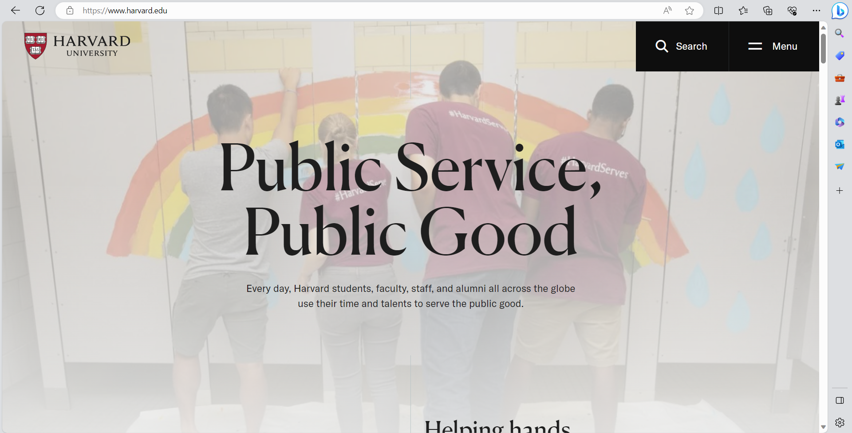

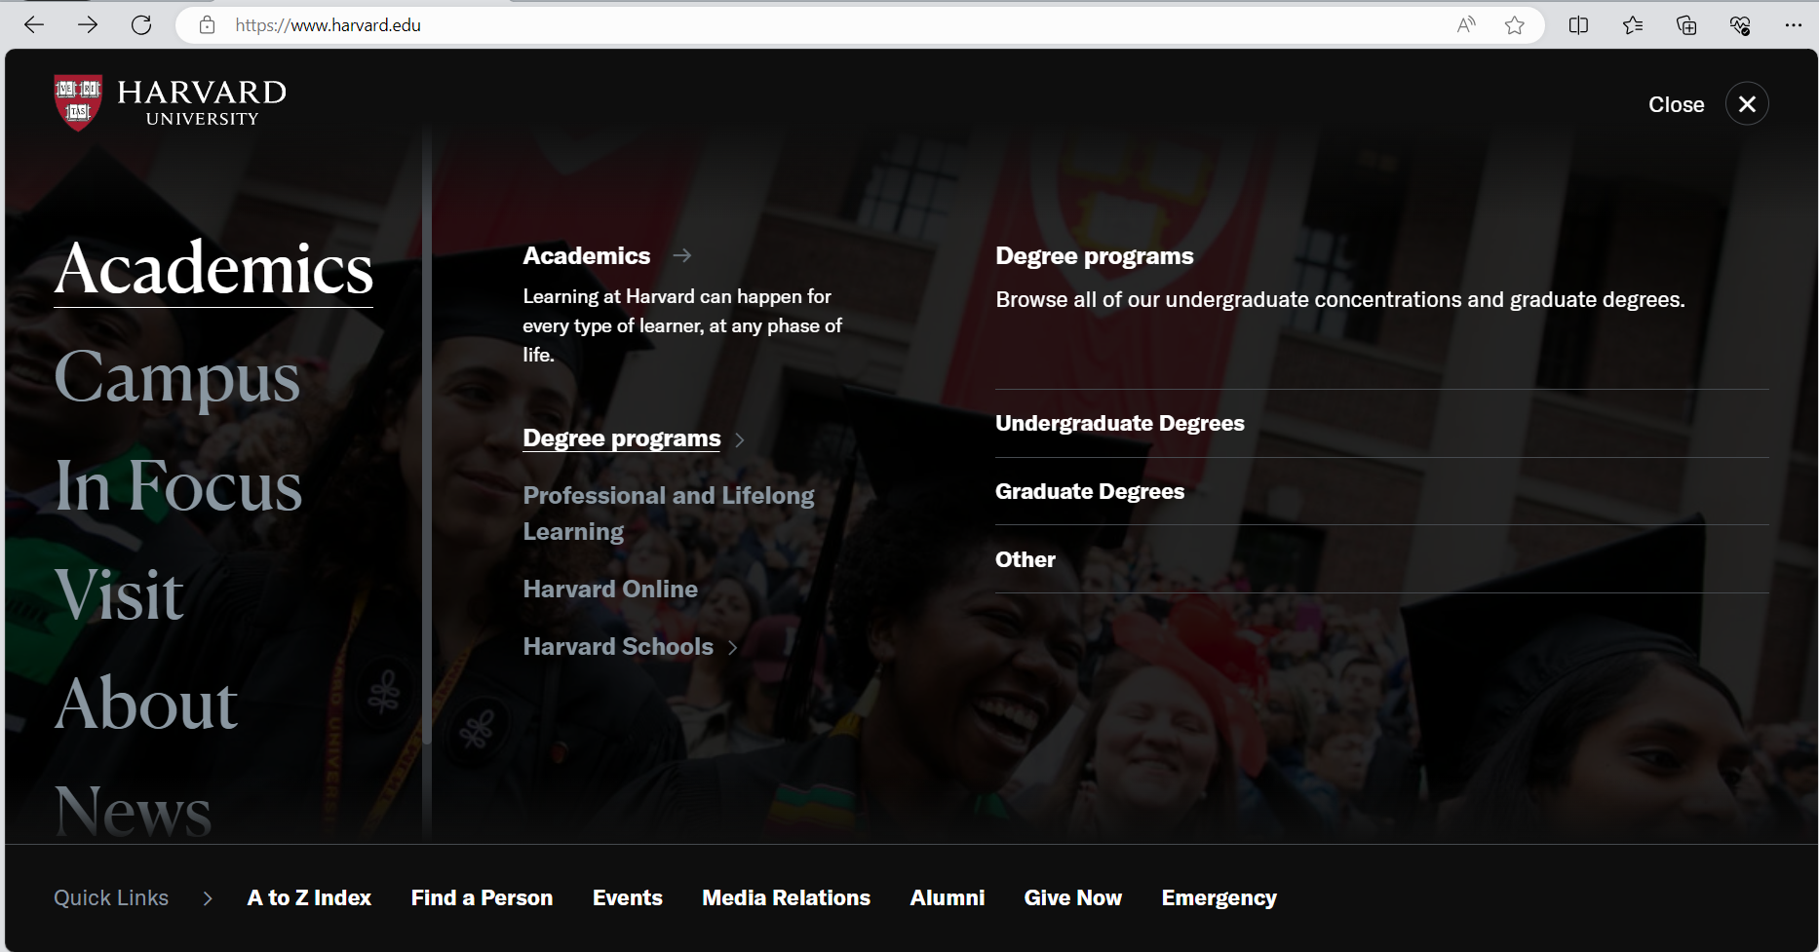

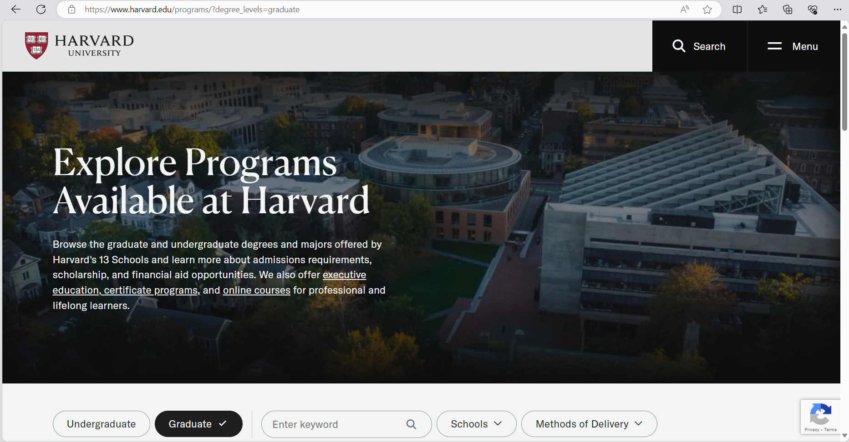

Stanford University (Canada)

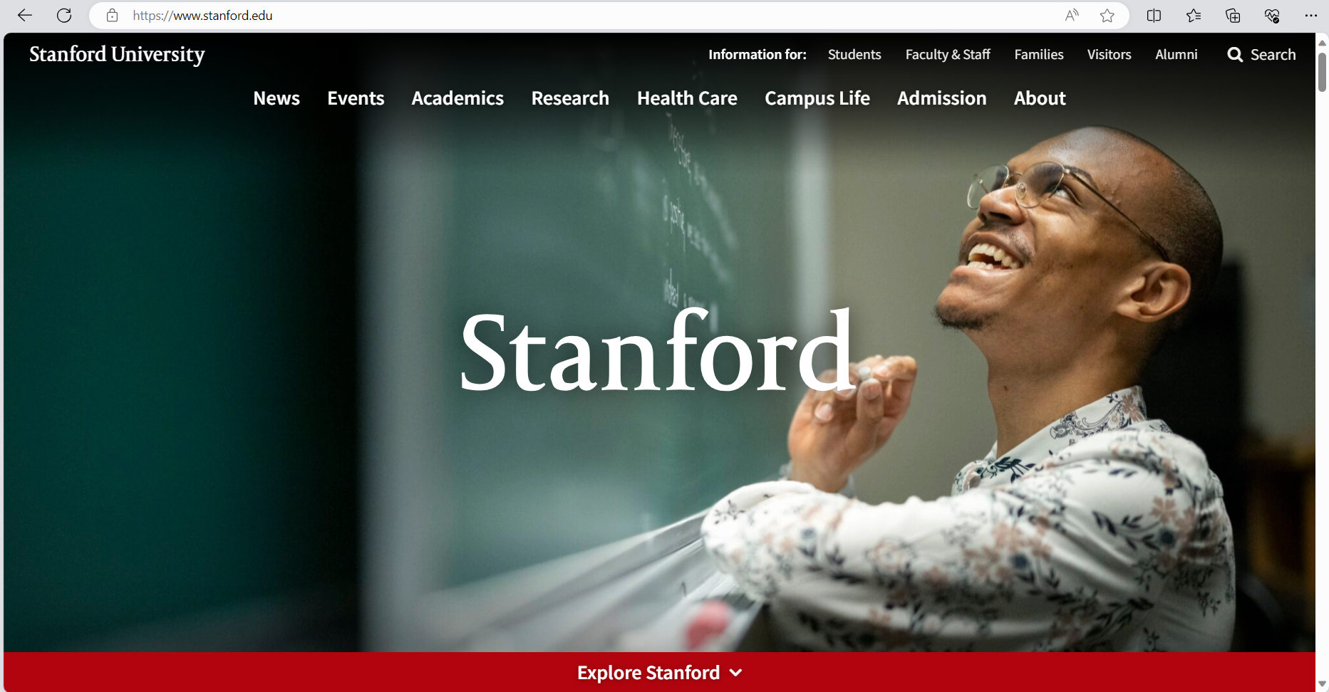

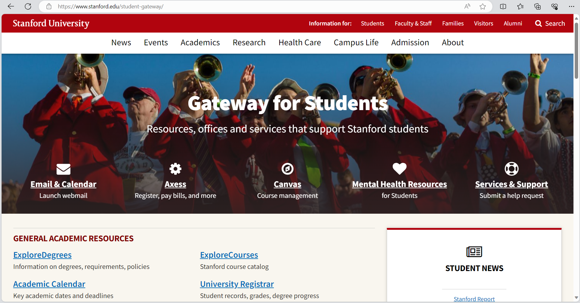

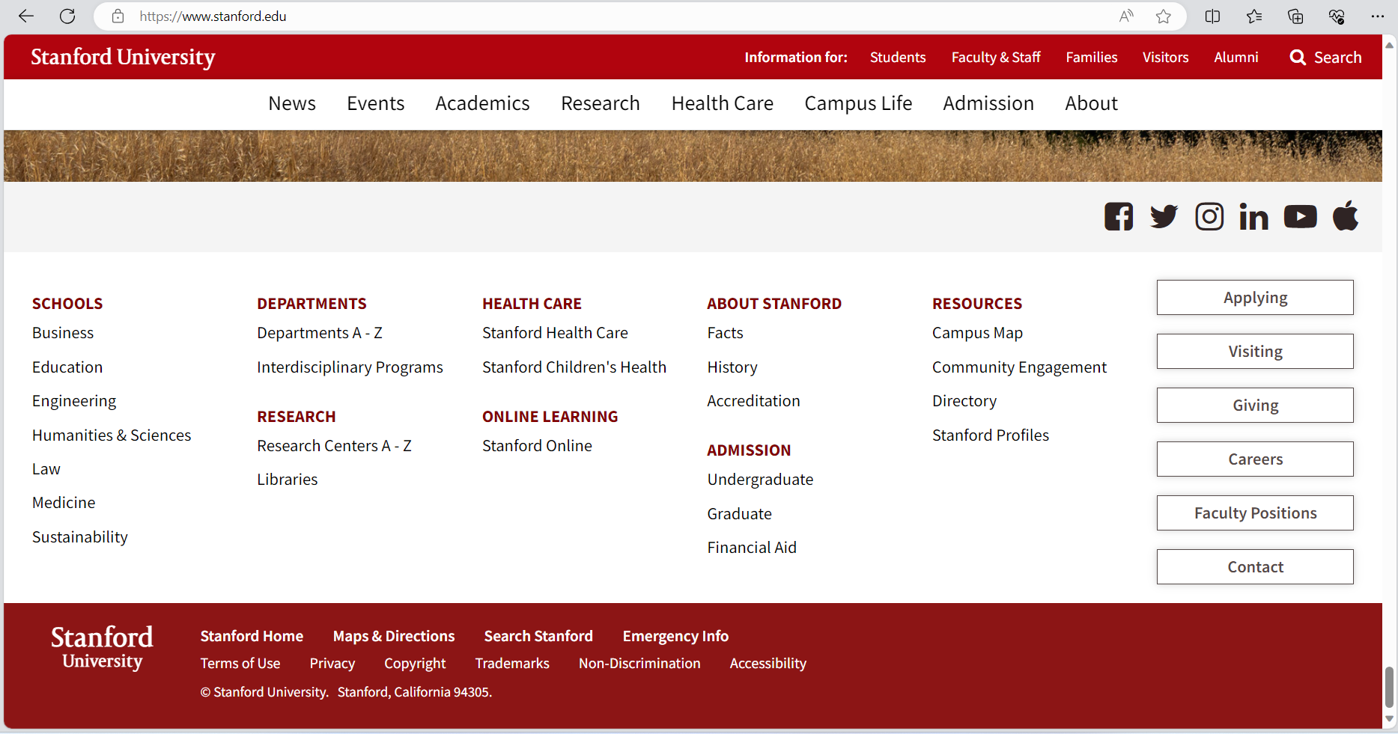

Imperial College London (London)

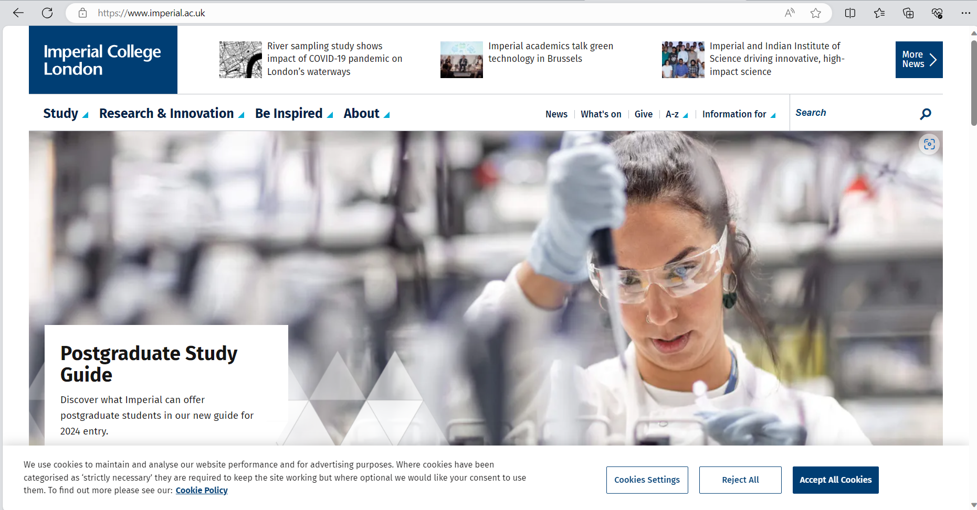

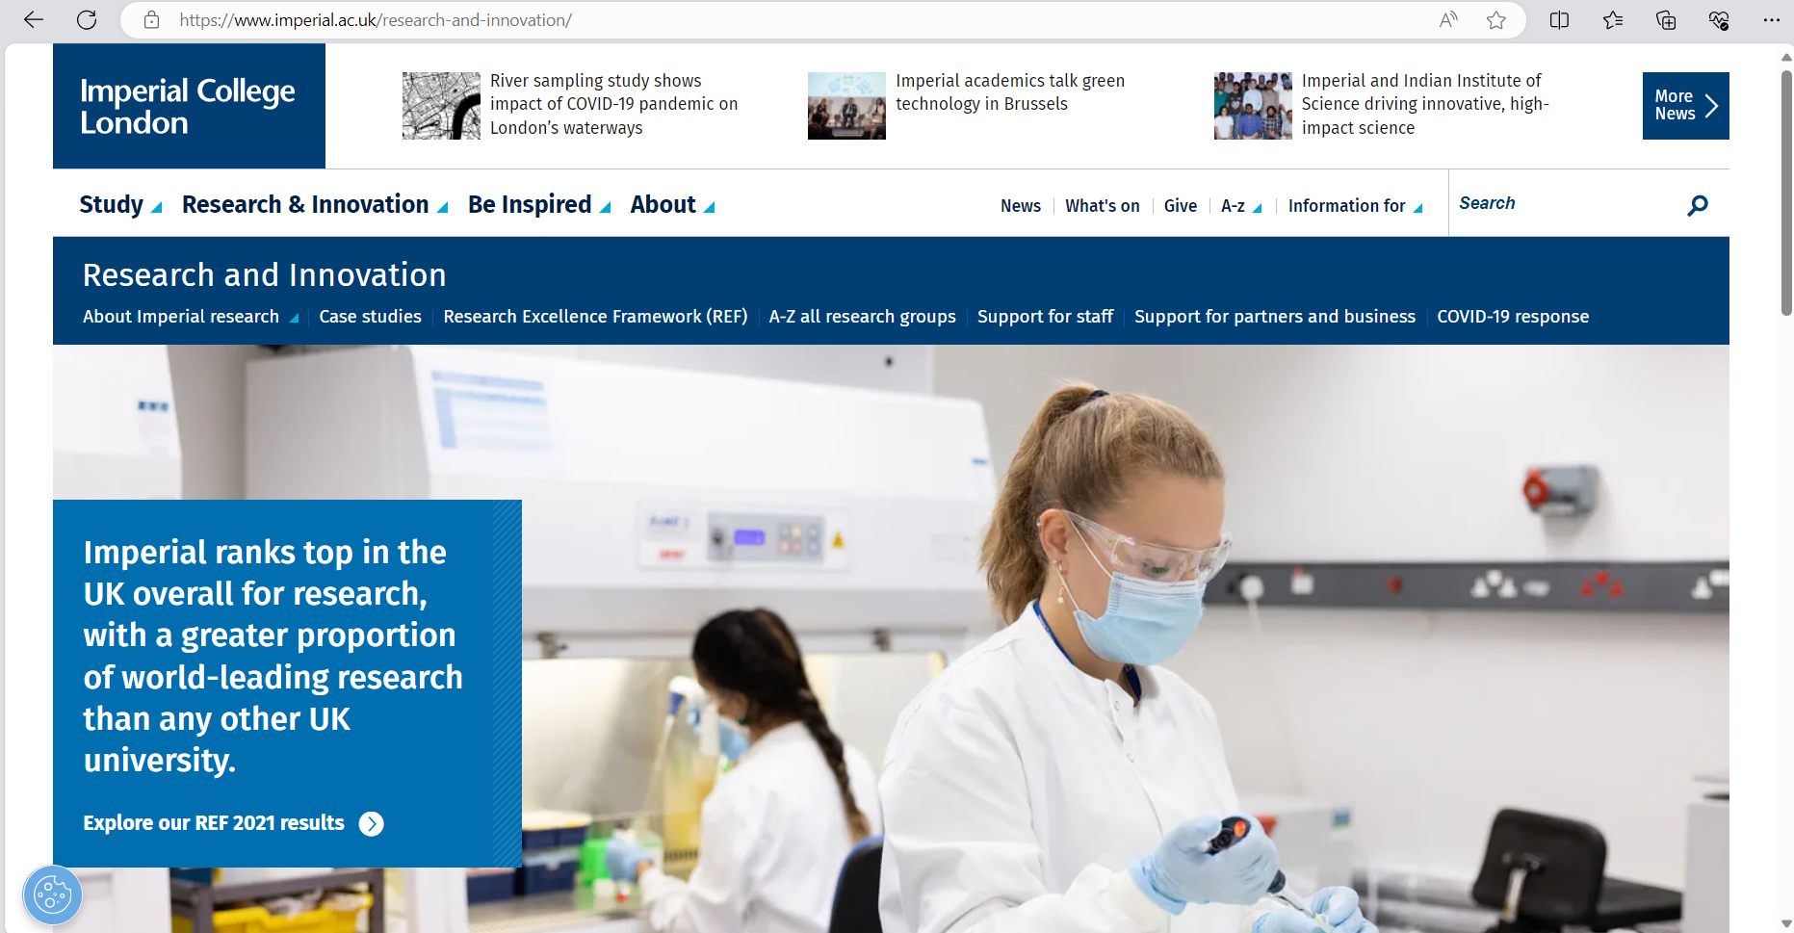

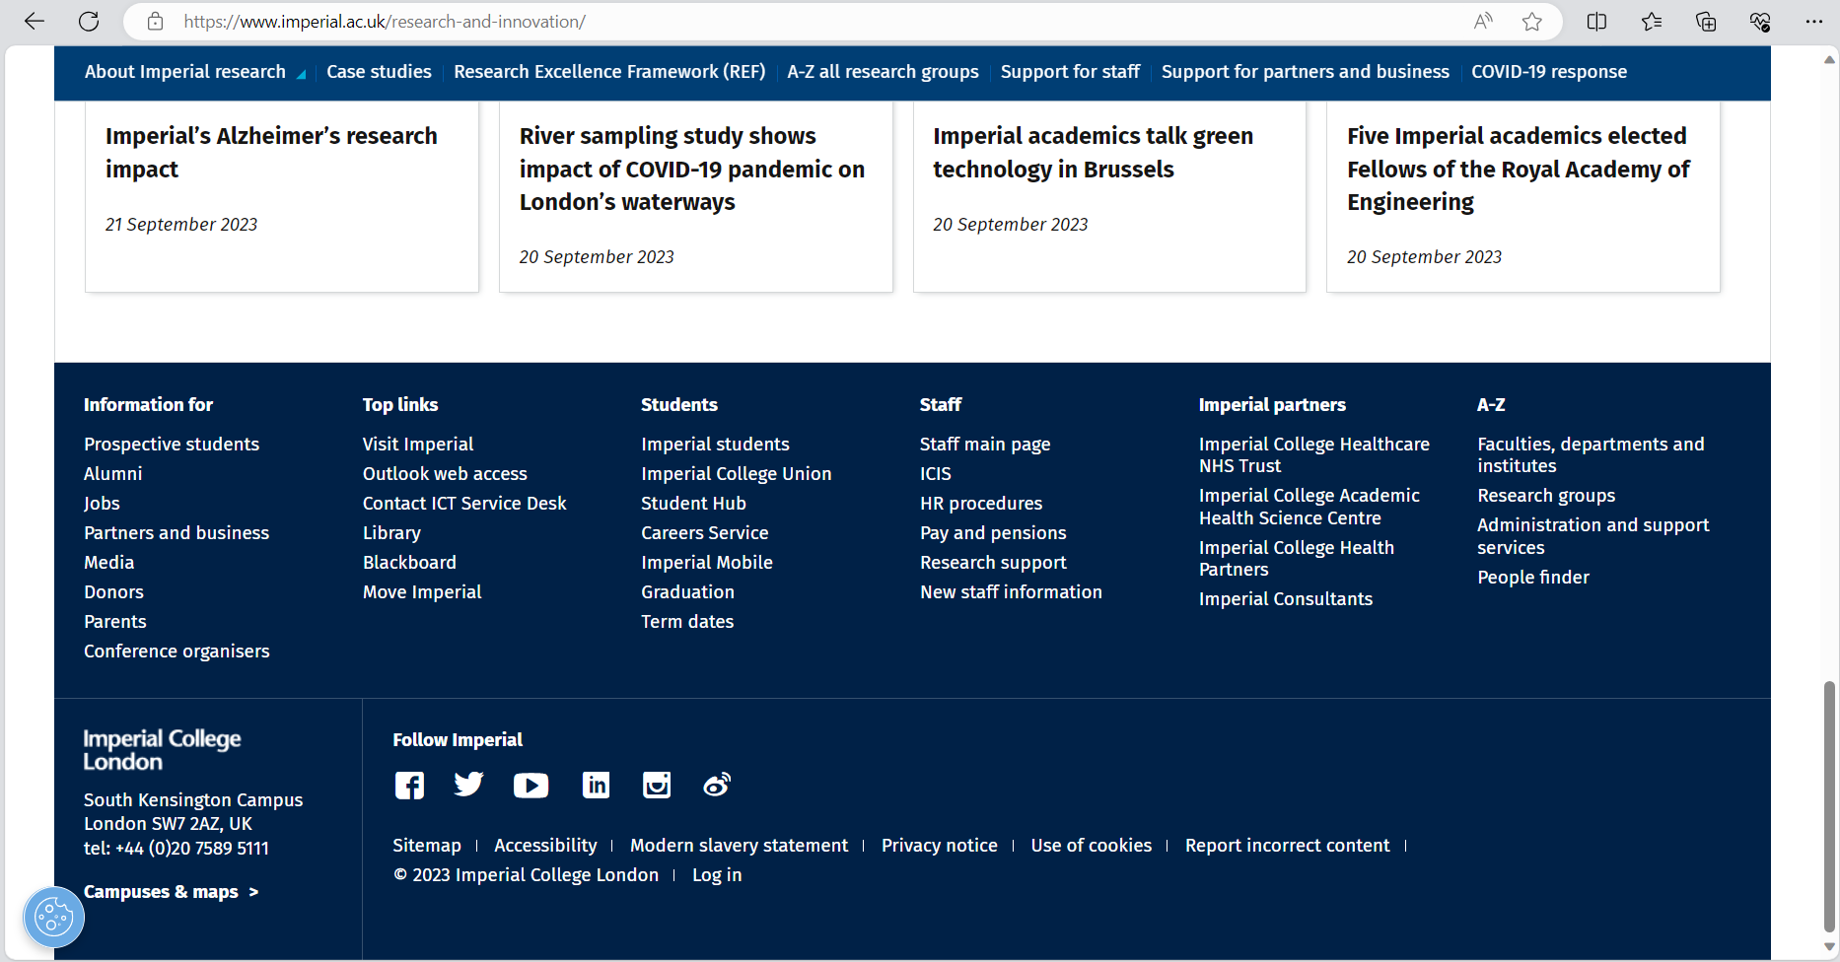

**Local System**

Ateneo De Manila



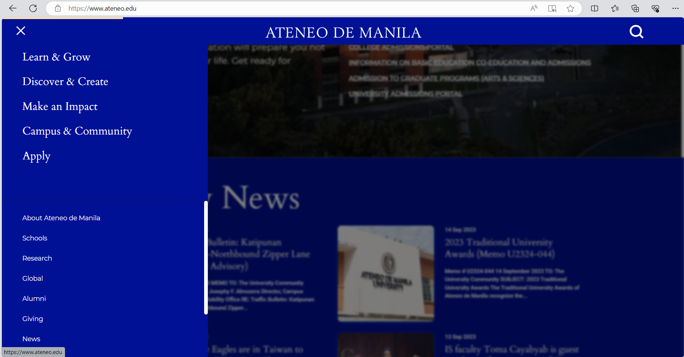

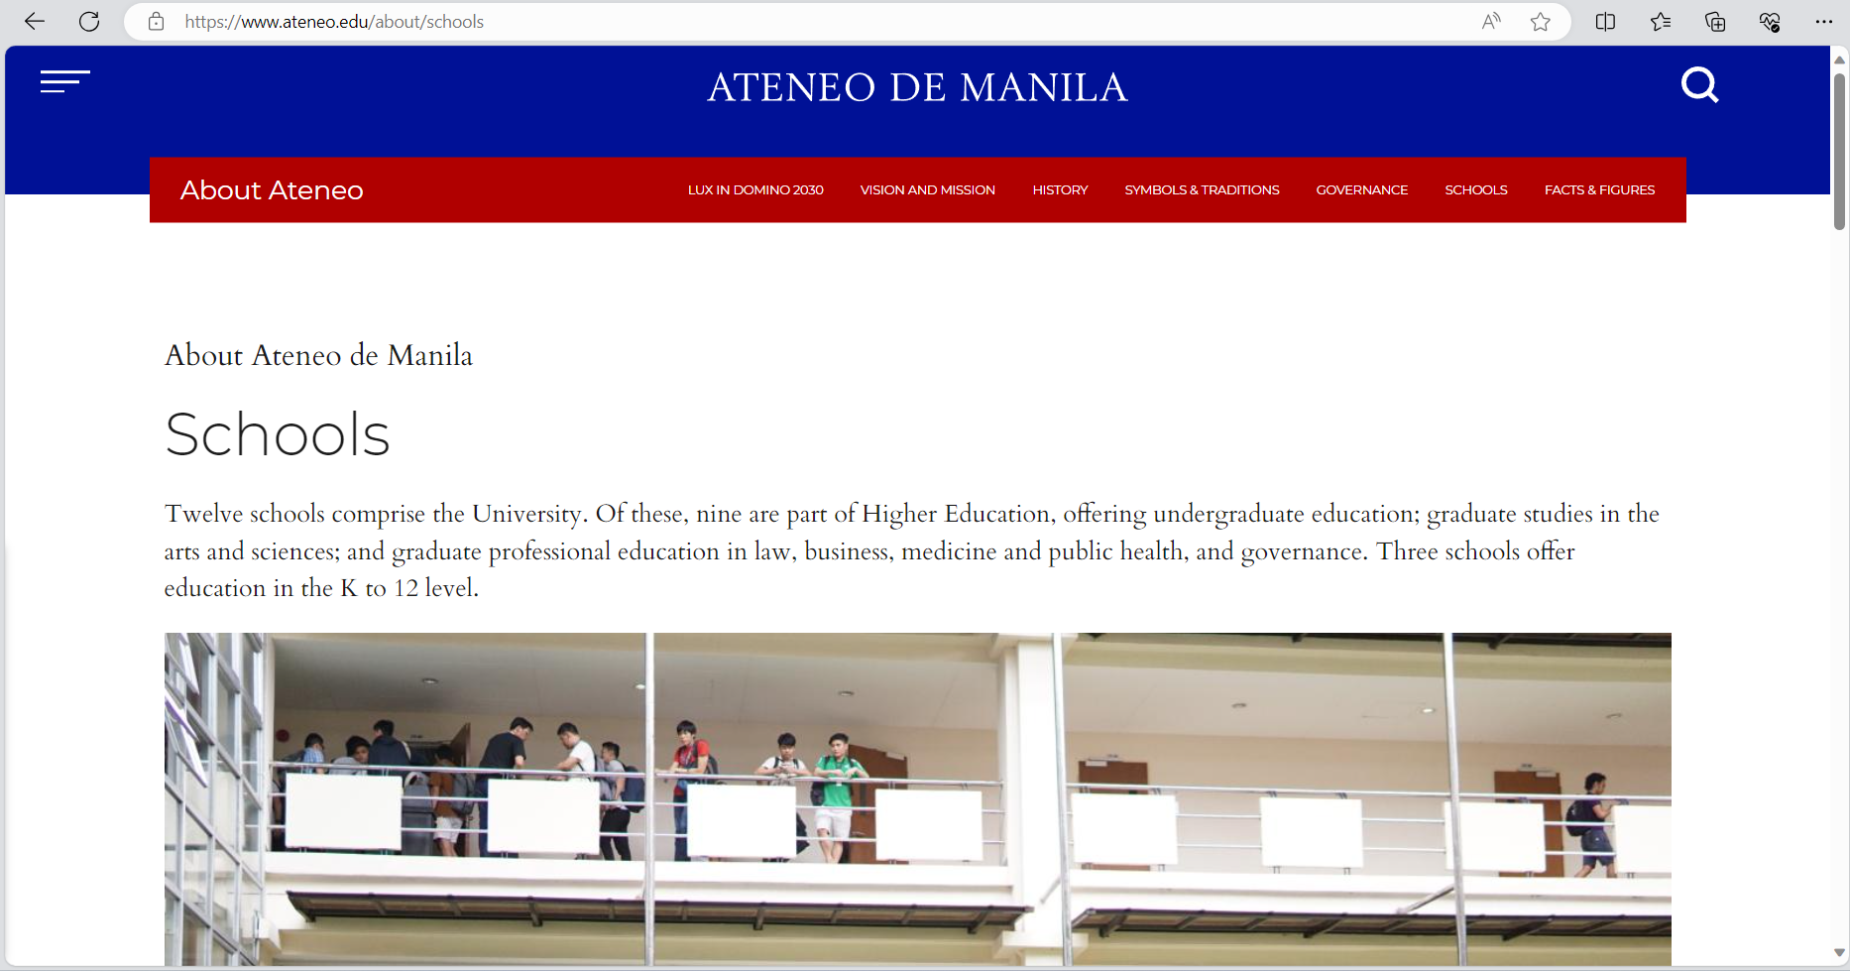

STI College

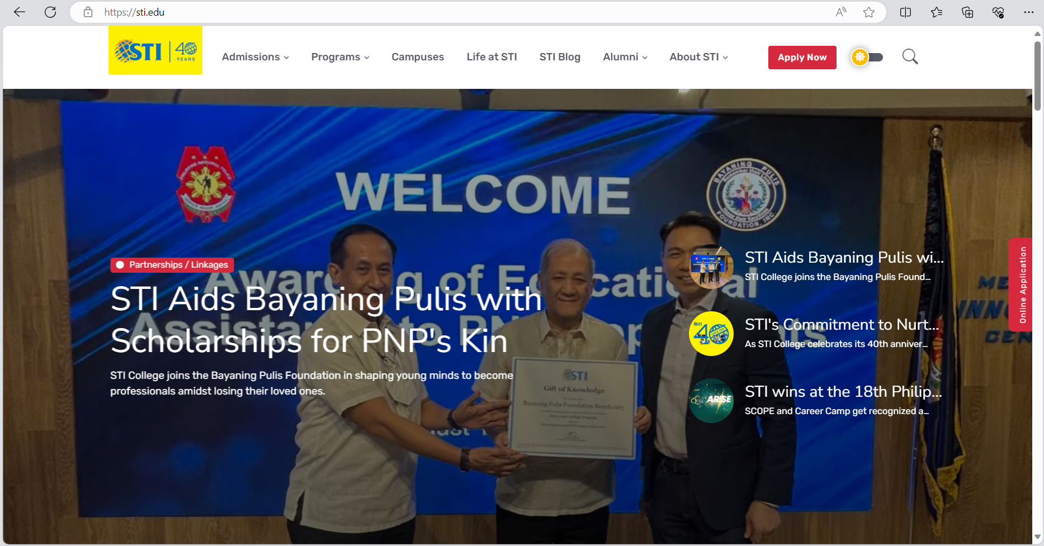

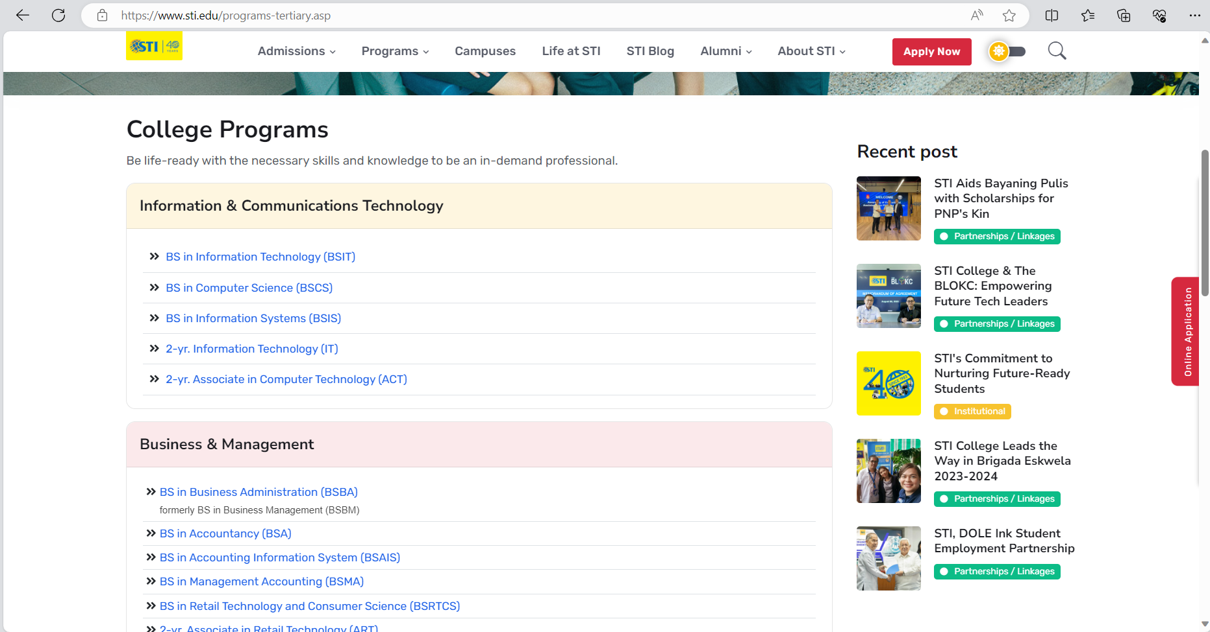



De La Salle University



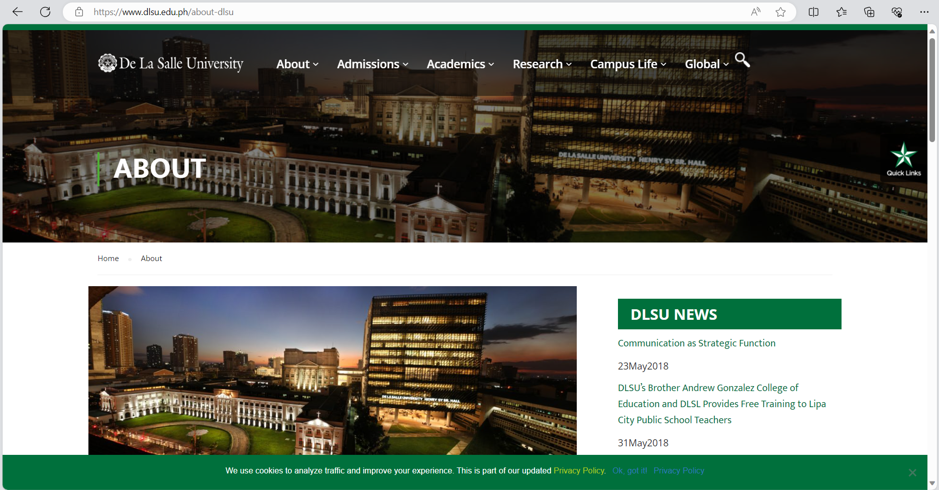

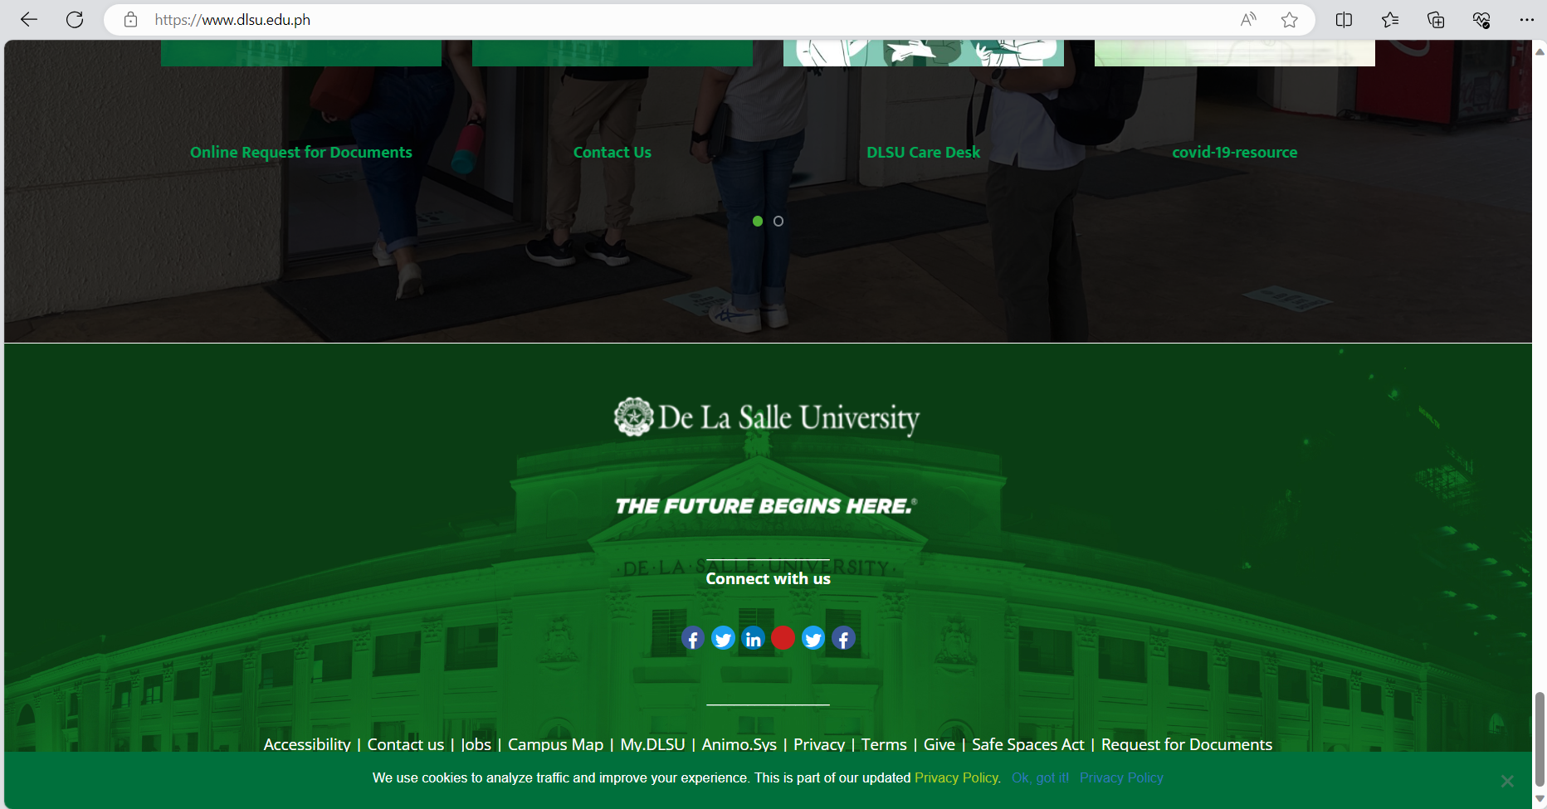

**Chapter III**

**Research Design**

The study used the survey design method, which involves gathering information from a large number of people using questionnaires or interviews. It is often used in social science research to collect data on attitudes, opinions, and behaviors. To further understand the survey design, according to (Mills, J. G., 2021)

*“Survey research refers to a particular type of research design where the primary method of data collection is by survey. In this study design, surveys are used as a tool by researchers to gain a greater understanding about individual or group perspectives relative to a particular concept or topic of interest.”*

To use survey design in research, the researcher first identifies the research question and the population to be surveyed. They then need to develop a set of questions that will provide relevant information. The survey should be administered to the sample population, and the data should be analyzed to draw conclusions and insights related to the research question. Finally, the findings should be presented in a clear and concise manner.

Based on the survey design method, the researchers gathered information regarding respondents' preferences for a school website. The survey aimed to identify the features and functionalities that the respondents would like to have on a school website, as well as the benefits they expect from such a platform. Additionally, the survey aimed to uncover any negative experiences that respondents may have had with other websites, particularly in the context of school-related platforms.

The information gathered through the survey provides valuable insights into the desired features of a school website. By understanding what the respondents want in terms of design, content, and functionality, the researchers can tailor the development of the website to meet their expectations. Furthermore, the survey helps identify the benefits that respondents associate with an ideal school website, such as improved communication, access to resources, or enhanced user experience.

**Population**

The active involvement of students, parents, and faculty members as primary stakeholders in shaping the school website's development is paramount. Their input will be harnessed through surveys, interviews, and usability testing, strategically conducted within the school community and, at times, via online platforms. By engaging these stakeholders directly, the project not only gathers valuable insights into their preferences and needs but also ensures that the website is designed with their real-world usage in mind. The benefits are twofold: it enhances the user experience by tailoring the website to their specific requirements, making it more user-friendly, and it maintains the website's relevance by continuously aligning it with the evolving expectations of the school community. This participatory approach fosters a sense of ownership among stakeholders, increasing their engagement in the project's success.

**Table of Population**

|  |  |
| --- | --- |
| **Respondents** | **Total** |
| First year College | 15 |
| Second year College | 15 |
| Third year College | 15 |
| Fourth year College | 15 |
| Faculty | 30 |
| Parents | 60 |

Table 1. *Tabular Presentation of Total Respondents*

**Formula**

The researcher used Slovin’s Formula to determine the appropriate sample size for their research study. By calculating the required sample size based on the population size and margin of error, the researcher was able to ensure that the sample size was large enough to produce accurate and reliable results.

The formula is expressed as follows: $$n= \frac{150}{2.5}$$

Sample Computation:

$$n= \frac{150}{1+150{\left(0.1\right)}^{2}}$$

$$n= \frac{150}{1+150{\left(0.01\right)}^{}}$$

$$n= \frac{150}{1+1.5}$$

$$n= \frac{150}{2.5}$$

$$n= 60$$

**Sample Table**

|  |  |  |
| --- | --- | --- |
| **Respondents** | **Total** | **Sample** |
| First year College | 15 | 6 |
| Second year College | 15 | 6 |
| Third year College | 15 | 6 |
| Fourth year College | 15 | 6 |
| Faculty | 30 | 12 |
| Parents | 60 | 24 |
|  |  | **Total Sample = 60** |

Table 2. *Tabular Presentation of Samples*

**Sample and Sampling Techniques**

**Random Sampling**

The use of simple random sampling in this research offers several benefits. By randomly selecting respondents from the population of interest, the researchers can ensure that the sample is representative and reflects the diversity and characteristics of the larger population. This increases the generalizability of the findings and enables broader insights and conclusions to be drawn about the preferences and experiences of the entire population. Moreover, random sampling helps to minimize bias and enhance the reliability and validity of the data collected.

**Data Gathering Tools**

Data gathering tools refer to the instruments or techniques employed to collect data for analysis. These tools can range from surveys and questionnaires to interviews, focus groups, and experimental methods. They help researchers systematically collect and organize data, ensuring accuracy and reliability in the research findings. Additionally, advancements in technology have introduced digital tools such as online surveys, data logging devices, and software for data analysis, which further enhance the efficiency and effectiveness of data gathering in research.

***Surveys/questionnaires:***

These are commonly used tools to gather data from a large number of participants. Surveys/questionnaires can be conducted online or in person and can be structured or unstructured. In the capstone project about creating a website for a school, surveys/questionnaires can be used to gather information from the school community, such as students, parents, and teachers, about their preferences, needs, and expectations for the website. The survey can include questions about the features they would like to see, their user experience, and any suggestions they have for improvement. Information gathered: The information gathered from surveys/questionnaires can include demographic information about the participants, their opinions and preferences on the website design, the features they would like to see, and their satisfaction with the website's usability. The information gathered from surveys/questionnaires can help in designing the website to meet the needs and preferences of the school community. The information can also be used to identify areas of improvement and to evaluate the effectiveness of the website.

***Observation***

This involves watching and recording behaviors or events in their natural setting. Observation can be structured or unstructured and can be used to gather data on behaviors or processes that may be difficult to obtain through other methods. In the capstone project about creating a website for a school, observation can be used to observe the school community's use of the current website. The observer can note the website's strengths and weaknesses, as well as any areas of improvement that need to be addressed in the new website. The information gathered from observation can include the website's current design and usability, the user experience, and any difficulties encountered by users. The information gathered from observation can help in designing the new website to address the weaknesses of the current website. It can also help in ensuring that the new website is user-friendly and addresses the needs of the school community.

***Secondary data analysis***

This involves the analysis of existing data that has been collected for other purposes. Secondary data can include publicly available data, such as census data, or data collected by other researchers. In the capstone project about creating a website for a school, secondary data analysis can be used to analyze existing data on website design and usability in other schools. This can include data on website traffic, user engagement, and best practices in website design. The information gathered from secondary data analysis can include website traffic data, user engagement data, and best practices in website design. The information gathered from secondary data analysis can help in designing the new website based on best practices in website design. It can also help in ensuring that the new website is user-friendly and addresses the needs of the school community.

***Internet Method***

The Internet method involves using the internet to gather data through various methods, such as online surveys/questionnaires, online interviews, web analytics, and social media analysis. In the capstone project about creating a website for a school, the internet method can be used to gather data through an online survey/questionnaire. The survey can be administered to the school community to gather information about their preferences, needs, and expectations for the website. The information gathered through the internet method can include demographic information about the participants, their opinions and preferences on the website design, the features they would like to see, and their satisfaction with the website's usability. The information gathered through the internet method can help in designing the website to meet the needs and preferences of the school community. The information can also be used to identify areas of improvement and to evaluate the effectiveness of the website. Additionally, web analytics can be used to track website traffic, user engagement, and other metrics to assess the website's performance and to identify areas of improvement. Social media analysis can also be used to gather data on the school community's attitudes and opinions towards the school and its website, which can inform the design of the new website.

**Chapter IV**

**Respondents of the Study**

This research project encompasses a total of 60 participants, which consists of 12 school faculty/personnel, 24 students, and 24 parents. Due to the manageable size of the population, the researcher opted for a total enumeration approach, including all individuals within the target group. The respondents were then categorized and distributed based on their respective role (faculty/personnel, students, parents) as well as their age groups, as relevant to the study.

**Respondents Profile by Role**

|  |  |  |
| --- | --- | --- |
| **Role** | **FREQUENCY** | **PERCENTAGE** |
| Students | 24 | 40% |
| Faculty/Personnel | 12 | 20% |
| Parent/Guardian | 24 | 40% |
| **TOTAL:** | 60 | 100% |

Table 3. *Tabular Presentation of Respondents by Role.*

The table shows the distribution of respondents based on their roles in the survey, with a total of 60 participants. Students constituted the largest group, representing 40% of the respondents, followed by Parent/Guardians, also at 40%. Faculty/Personnel made up the remaining 20%. In summary, the survey had an equal proportion of Students and Parent/Guardians, while Faculty/Personnel had a smaller representation.

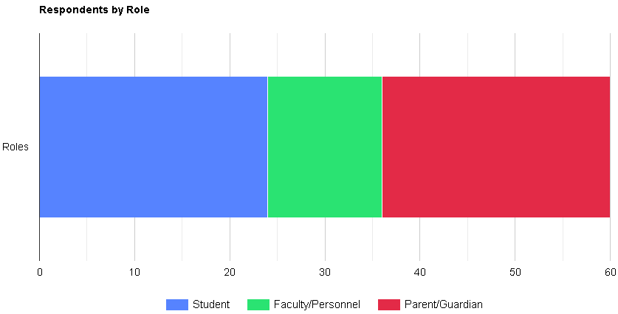

Graph 1. *Graphical Presentation of Respondents by Role.*

The graph provided is a structured representation of the data collected from respondents arranged by their roles. Observe that 40% of the respondents identify as parents, 40% as students, and 20% as faculty members. The table allows for a clear representation of these percentages and provides an overview of the composition of the respondents based on their roles in a graphical form.

**Respondents Profile by Age**

|  |  |  |
| --- | --- | --- |
| **Age** | **FREQUENCY** | **PERCENTAGE** |
| 19-29 | 27 | 45% |
| 30-39 | 10 | 16.7% |
| 40-49 | 15 | 25% |
| 50-69 | 8 | 13.3% |
| **TOTAL** | **60** | **100%** |

Table 4. *Tabular Presentation of Respondents by Age.*

The table presents the distribution of respondents based on their age in a survey with a total of 60 participants. The largest age group was 19-29, accounting for 45% of respondents, followed by the 40-49 age group with 25%. The 30-39 age group represented 16.7% of participants, while the 50-69 age group constituted 13.3%. In summary, the majority of respondents were in the 19-29 age range, with notable representation from the 40-49 age bracket, while the 30-39 and 50-69 groups had relatively fewer respondents.

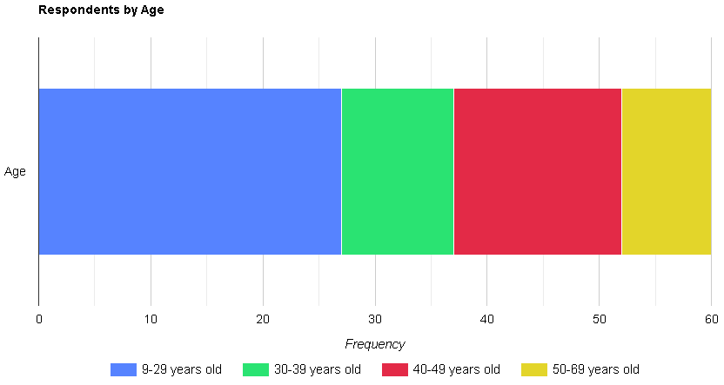

Graph 2. *Graphical Presentation of Respondents by Age.*

**Result of Information Extraction Questionnaire**

|  |  |  |  |  |
| --- | --- | --- | --- | --- |
| **1. Q: Do you want the following information to be included in the proposed LCCV Website?** | | | | |
| Factor | Yes | | No | |
|  | **Frequency** | **Percentage** | **Frequency** | **Percentage** |
| 1. School Background | 58 | 96.67% | 2 | **3.33%** |
| 1. Core Values | 60 | 100% | 0 | 0 |
| 1. Top Faculty Members | 59 | 96.33% | 1 | 1.67% |
| 1. Vision-Mission | 60 | 100% | 0 | 0 |
| 1. School Announcement | 59 | 96.33% | 1 | 1.67% |
| **Others Please Specify:** 2 responses (Role model, School’s background history, School’s facilities/ features) | | | | |

Table 5. *Tabular representation of the summary result for question number 1.*

The table displays the responses to the question of whether respondents want specific information to be included on the proposed LCCV (LCCV Website). The factors listed include School Background, Core Values, Top Faculty Members, Vision-Mission, and School Announcement. For School Background, 58 respondents answered "Yes," indicating their desire to include this information, while only 2 respondents answered "No," representing a small minority. This resulted in a frequency of 60 and a percentage of 96.67% for "Yes," with a corresponding frequency of 2 and a percentage of 3.33% for "No." Regarding Core Values, all 60 respondents expressed their preference for this information to be included, as there were no "No" responses. Therefore, the frequency for "Yes" was 60, accounting for 100% of the respondents, while the frequency for "No" was 0. Similarly, for Top Faculty Members, 59 respondents answered "Yes," while only 1 respondent answered "No." The frequency for "Yes" was 59, representing 96.33% of the total respondents, and the frequency for "No" was 1, accounting for 1.67%. In terms of Vision-Mission, all 60 respondents indicated their preference to include this information, resulting in a frequency of 60 and a percentage of 100% for "Yes." There were no "No" responses, yielding a frequency of 0 and a percentage of 0% for "No." Lastly, for School Announcement, 59 respondents wanted this information to be included, while 1 respondent expressed a preference for it not to be included. This led to a frequency of 59 and a percentage of 96.33% for "Yes," and a frequency of 1 and a percentage of 1.67% for "No." In summary, the data reveals a strong consensus among respondents for the inclusion of Core Values, Vision-Mission, and School Announcement on the proposed LCCV Website. Additionally, School Background and Top Faculty Members were also widely supported, with only a small number of respondents suggesting their exclusion.

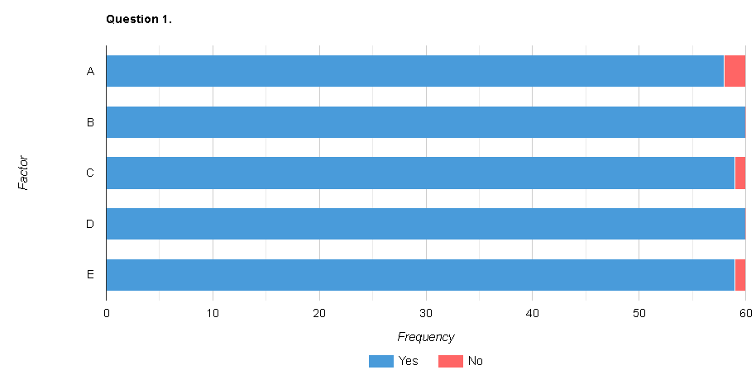

Graph 3. *Graphical Presentation of the summary result for question number 1.*

In the chart, we can observe that for the factor "School Background," the majority of respondents, totaling 58, answered "Yes," indicating their preference to include this information in the proposed system. Only 2 respondents answered "No," suggesting a minor dissenting opinion. For the factor "Core Values," all 60 respondents answered "Yes," reflecting unanimous agreement to include this aspect in the proposed system. There were no "No" responses for this factor. The factor "Top Faculty Members" received a high number of "Yes" responses, with 59 respondents in favor of including this information. Only 1 respondent answered "No," indicating a minimal opposition to this feature. Similarly, the factors "Vision-Mission" and "School Announcement" received overwhelming support, with all 60 respondents answering "Yes" for both factors. There were no "No" responses for these factors, indicating unanimous agreement. Overall, the stacked bar chart clearly illustrates the strong consensus among the respondents to include the mentioned factors in the proposed system. The chart highlights the high frequency of "Yes" responses, underscoring the unanimous or near-unanimous agreement on incorporating these elements into the system.

|  |  |  |  |  |
| --- | --- | --- | --- | --- |
| **2. Q: Currently, do you experience the following difficulties in the LCCV's Official Website?** | | | | |
| Factor | Yes | | No | |
|  | **Frequency** | **Percentage** | **Frequency** | **Percentage** |
| 1. Outdated Information and Announcements about the School | 45 | 75% | 15 | 25**%** |
| 1. Poor Navigation of Content | 38 | 63.33% | 22 | 36.67% |
| 1. Lack of Accessibility in Important Information and Announcement | 41 | 68.33% | 19 | 31.67% |
| 1. Technical Issues on Buttons | 40 | 66.67% | 20 | 33.33% |
| 1. Limited Content | 47 | 78.33% | 13 | 21.67% |
| 1. Poor usage of colors and fonts | 38 | 63.33% | 22 | 36.67% |
| **Others Please Specify:** 1 response (Financial management course) | | | | |

Table 6. *Tabular representation of the summary result for question number 2.*

The table presents the responses to the question regarding the difficulties experienced by respondents on the LCCV's Official Website. a) Outdated Information and Announcements about the School: Of the 60 respondents, 45 indicated that they have experienced difficulties due to outdated information and announcements on the website, while 15 respondents reported not encountering such issues. This represents a significant concern for 75% of the respondents, while 25% did not experience this problem. b) Poor Navigation of Content: Among the respondents, 38 individuals expressed difficulty in navigating the content on the website, while 22 respondents did not encounter this issue. This signifies that approximately 63.33% of the participants faced challenges related to content navigation, while 36.67% did not experience such difficulties. c) Lack of Accessibility in Important Information and Announcements: In terms of accessibility, 41 respondents stated that they faced problems accessing important information and announcements on the website. Conversely, 19 respondents did not encounter accessibility issues. This highlights a concern for approximately 68.33% of the respondents, while 31.67% did not face such obstacles. d) Technical Issues on Buttons: For technical issues related to buttons on the website, 40 respondents reported experiencing difficulties, while 20 respondents did not encounter any problems. This indicates that approximately 66.67% of the participants faced technical challenges with buttons, while 33.33% did not have such issues. e) Limited Content: Out of the respondents, 47 individuals expressed that they experienced difficulties due to limited content on the website, while 13 respondents did not face this problem. This signifies a concern for approximately 78.33% of the participants, while 21.67% did not encounter limited content issues. f) Poor usage of colors and fonts: Regarding the usage of colors and fonts, 38 respondents reported facing challenges due to poor implementation on the website, while 22 respondents did not have any concerns in this regard. This indicates that approximately 63.33% of the participants found the colors and fonts to be problematic, while 36.67% did not share this sentiment. In summary, the data reveals several areas of difficulty experienced by respondents on the LCCV's Official Website, including outdated information and announcements, poor navigation of content, lack of accessibility in important information and announcements, technical issues on buttons, limited content, and poor usage of colors and fonts. These insights provide valuable feedback for the improvement and enhancement of the website's user experience.

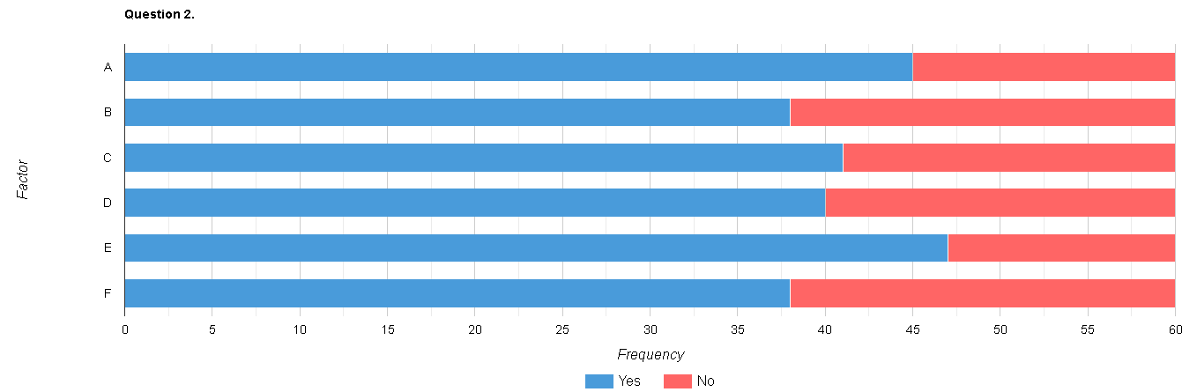

Graph 4. *Graphical Presentation of the summary result for question number 2.*

In the stacked bar chart, the factor "Outdated Information and Announcements about the School" shows that 45 respondents, accounting for 75% of the total, answered "Yes," indicating their desire to address this issue. On the other hand, 15 respondents, representing 25%, answered "No," indicating disagreement or a lack of concern regarding this factor. The factor "Poor Navigation of Content" displays a split opinion among respondents. 38 respondents, or approximately 63.33%, answered "Yes," indicating their concern about this issue, while 22 respondents, accounting for about 36.67%, answered "No," suggesting a differing perspective or a lack of priority regarding this factor. Similarly, for the factor "Lack of Accessibility in Important Information and Announcement," 41 respondents, or around 68.33%, expressed a desire to address this issue by answering "Yes." In contrast, 19 respondents, making up approximately 31.67%, answered "No," indicating either a lack of concern or a different viewpoint on this matter. The factor "Technical Issues on Buttons" received responses from 40 individuals, comprising roughly 66.67% of the respondents, who acknowledged this issue and answered "Yes." Conversely, 20 respondents, accounting for approximately 33.33%, answered "No," indicating a differing opinion or a perceived lack of importance for this factor. Regarding the factor "Limited Content," the majority of respondents, 47 in total or around 78.33%, expressed a desire for improvement by answering "Yes." Conversely, 13 respondents, making up approximately 21.67%, answered "No," indicating either satisfaction with the current content or a lack of concern about this factor. Lastly, the factor "Poor usage of colors and fonts" garnered responses from 38 individuals, representing approximately 63.33%, who acknowledged this issue and answered "Yes." On the other hand, 22 respondents, accounting for around 36.67%, answered "No," indicating a differing perspective or a lack of concern regarding this factor.

|  |  |  |  |  |
| --- | --- | --- | --- | --- |
| **3. Q: Do you want the following features to be included in the LCCV Official Website?** | | | | |
| Factor | Yes | | No | |
|  | **Frequency** | **Percentage** | **Frequency** | **Percentage** |
| 1. About Us | 58 | 96.67% | 2 | 3.33% |
| 1. Programs and Courses | 59 | 98.33% | 1 | 1.67% |
| 1. Campus Life | 53 | 88.33% | 7 | 11.67% |
| 1. Announcements | 58 | 96.67% | 2 | 3.33% |
| 1. School Calendar | 60 | 100% | 0 | 0 |
| 1. Contact Information | 57 | 95% | 3 | 5% |
| **Others Please Specify:** 0 response | | | | |

Table 7. *Tabular representation of the summary result for question number 3.*

The table represents the responses to the question regarding desired features to be included in the LCCV Official Website. a) About Us: Out of the 60 respondents, 58 expressed the desire to include the "About Us" feature on the website, while only 2 respondents did not want this feature. This indicates a strong preference for including information about the institution, with 96.67% of the respondents in favor and 3.33% opposed. b) Programs and Courses: The majority of respondents, 59 out of 60, expressed the desire to include the "Programs and Courses" feature on the website. Only 1 respondent did not want this feature, demonstrating a high preference of 98.33% in favor and 1.67% opposed. c) Campus Life: Of the 60 respondents, 53 indicated that they wanted to have the "Campus Life" feature included on the website, while 7 respondents did not desire this feature. This represents a preference of 88.33% in favor and 11.67% opposed. d) Announcements: Similar to the "About Us" feature, the "Announcements" feature received significant support from respondents. 58 out of 60 respondents expressed the desire to include announcements on the website, with only 2 respondents not in favor. This reflects a preference of 96.67% in favor and 3.33% opposed. e) School Calendar: The "School Calendar" feature received unanimous support, with all 60 respondents wanting it to be included on the website. This represents 100% of the respondents in favor of including the school calendar feature. f) Contact Information: The majority of respondents, 57 out of 60, expressed the desire to include the "Contact Information" feature on the website, while 3 respondents did not want this feature. This indicates a preference of 95% in favor and 5% opposed. In summary, the data highlights the strong desire of respondents to include features such as "About Us," "Programs and Courses," "Campus Life," "Announcements," "School Calendar," and "Contact Information" on the LCCV Official Website. These insights provide valuable feedback for website development and cater to the preferences of the majority of respondents.

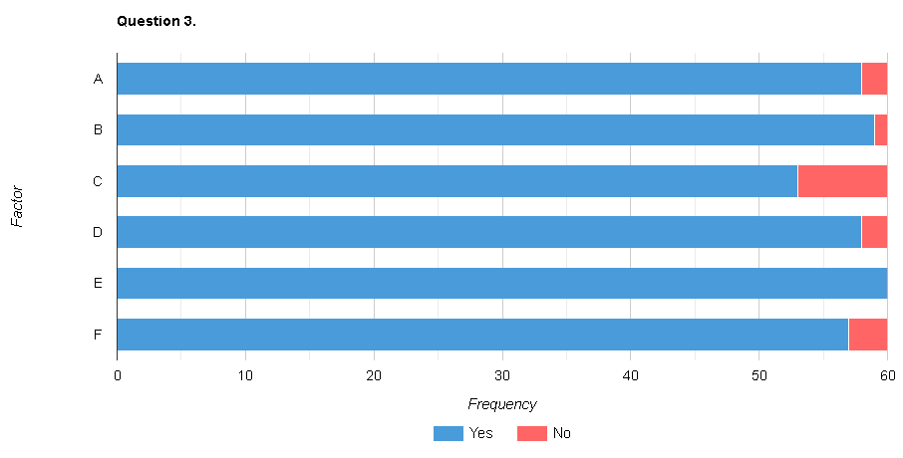

Graph 5. *Graphical Presentation of the summary result for question number 3.*

Starting with the factor "About Us," we can observe that 58 respondents answered "Yes," indicating their desire to include this information in the proposed system. Only 2 respondents answered "No," suggesting a small number of individuals who did not see the need for including "About Us" details. For the factor "Programs and Courses," the majority of respondents, totaling 59, responded with "Yes," indicating their preference for including this information. Only 1 respondent answered "No," signifying a minor dissenting opinion. Regarding "Campus Life," 53 respondents expressed their interest in including this aspect, representing 88.33% of the total respondents. Conversely, 7 respondents answered "No," reflecting a small percentage of individuals who did not see the relevance of incorporating "Campus Life" details. The factor "Announcements" received a high number of "Yes" responses, with 58 respondents in favor of including this information in the proposed system. Similar to the "About Us" factor, 2 respondents answered "No," suggesting a minor dissenting view. The factors "School Calendar" and "Contact Information" received overwhelming support from all respondents. For "School Calendar," all 60 respondents answered "Yes," indicating unanimous agreement. There were no "No" responses for this factor. Similarly, "Contact Information" received a high percentage of "Yes" responses, with 57 respondents expressing their preference to include it, while 3 respondents answered "No." Overall, the stacked bar chart illustrates a strong consensus among the respondents regarding the inclusion of these factors in the proposed system. The predominance of "Yes" responses and the minimal number of "No" responses highlight the collective agreement on incorporating these elements.

|  |  |  |  |  |
| --- | --- | --- | --- | --- |
| **4. Q: Does the following be considered as benefits of the proposed system entitled "Creating an Accessible and Inclusive Website for La Consolacion College Valenzuela: Meeting the Needs of All Users"?** | | | | |
| Factor | Yes | | No | |
|  | **Frequency** | **Percentage** | **Frequency** | **Percentage** |
| 1. Quick access to information | 59 | 98.33% | 1 | 1.67% |
| 1. Improved communication between the school and stakeholders | 60 | 100% | 0 | 0 |
| 1. Centralized information of the school | 53 | 88.33% | 7 | 11.67% |
| 1. Cost-effective | 57 | 95% | 3 | 5% |
| **Others Please Specify:** 1 response (Less of the school stakeholders) | | | | |

Table 8. *Tabular representation of the summary result for question number 4.*

The table represents the responses to the question regarding the benefits of the proposed system, "Creating an Accessible and Inclusive Website for La Consolacion College Valenzuela: Meeting the Needs of All Users." The respondents were asked to indicate their agreement or disagreement with each benefit, and the table provides the corresponding frequencies and percentages. a) Quick access to information: Out of the 60 respondents, 59 agreed that quick access to information is a benefit of the proposed system, while only 1 respondent disagreed. This indicates a strong consensus, with 98.33% of the respondents acknowledging this benefit and 1.67% expressing disagreement. b) Improved communication between the school and stakeholders: All 60 respondents agreed that the proposed system would lead to improved communication between the school and stakeholders. This unanimous agreement demonstrates a high level of confidence in the potential benefits of the system, with 100% of the respondents recognizing this advantage. c) Centralized information of the school: Of the 60 respondents, 53 agreed that centralized information of the school is a benefit of the proposed system, while 7 respondents disagreed. This represents a majority agreement of 88.33%, with 11.67% expressing disagreement. d) Cost-effective: The majority of respondents, 57 out of 60, agreed that the proposed system would be cost-effective, while 3 respondents disagreed. This indicates a preference of 95% in favor of perceiving the system as cost-effective, with 5% expressing disagreement. In summary, the data reflects a high level of agreement among the respondents regarding the benefits of the proposed system. The benefits acknowledged include quick access to information, improved communication between the school and stakeholders, centralized information of the school, and cost-effectiveness. These insights highlight the perceived advantages of the proposed system in creating an accessible and inclusive website for La Consolacion College Valenzuela and meeting the needs of all users.

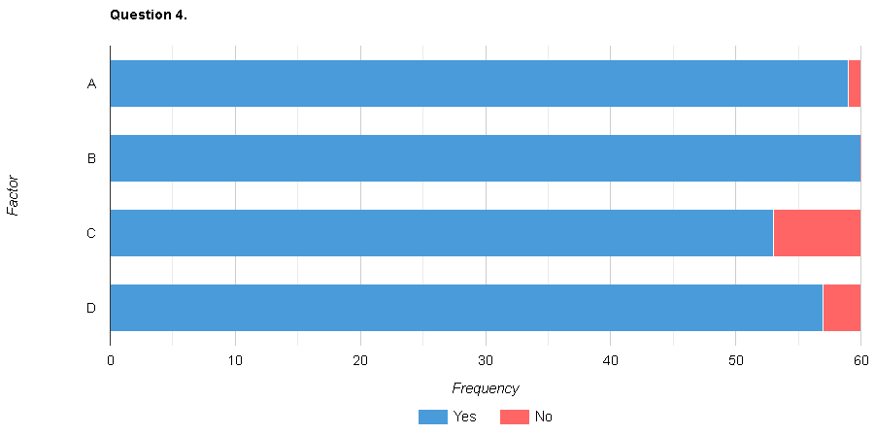

Graph 6. *Graphical Presentation of the summary result for question number 4.*

|  |  |  |  |  |
| --- | --- | --- | --- | --- |
| **5. The following criteria included in ISO 20510 needed to be considered in a system entitled “Creating an Accessible and Inclusive Website for La Consolacion College Valenzuela: Meeting the Needs of All Users”** | | | | |
| Factor | Yes | | No | |
|  | **Frequency** | **Percentage** | **Frequency** | **Percentage** |
| **Functional Sustainability:** |  |  |  |  |
| 1. Ease of Navigation | 60 | 100% | 0 | 100% |
| 1. Provides up to date Information | 60 | 100% | 0 | 100% |
| 1. Provides needed Information about the School | 60 | 100% | 0 | 100% |
| 1. User-friendly Interface | 60 | 100% | 0 | 100% |
| **Performance Efficiency:** |  |  |  |  |
| Regularly Updated | 60 | 100% | 0 | 100% |
| Includes Useful Information | 60 | 100% | 0 | 100% |
| **Compatibility:** |  |  |  |  |
| a) Compatibility to all types of Operating Systems | 60 | 100% | 0 | 100% |
| **Usability:** |  |  |  |  |
| 1. Up to date Information | 60 | 100% | 0 | 100% |
| 1. Legit Information | 60 | 100% | 0 | 100% |
| **Reliability:** |  |  |  |  |
| 1. Prevent Unauthorized Access | 60 | 100% | 0 | 100% |
| 1. Trusted Path | 60 | 100% | 0 | 100% |
| 1. User Data Protection | 60 | 100% | 0 | 100% |

Table 9. *Tabular representation of the summary result for question number 5.*

The table presents the responses regarding whether the following criteria should be considered as benefits of the proposed system entitled "Creating an Accessible and Inclusive Website for La Consolacion College Valenzuela: Meeting the Needs of All Users." The respondents were asked to indicate whether they agreed (Yes) or disagreed (No) with each criterion. The frequency and percentage of responses are provided. The criteria can be categorized into different aspects. Under the category of Functional Sustainability, all four criteria received unanimous agreement from all 60 respondents, indicating that they consider these aspects to be important benefits. These criteria include "Ease of Navigation," "Provides up-to-date Information," "Provides needed Information about the School," and "User-friendly Interface." Moving on to Performance Efficiency, the criteria of "Regularly Updated" and "Includes Useful Information" also received unanimous agreement from all respondents, highlighting their importance as benefits of the proposed system. In terms of Compatibility, the criterion of "Compatibility to all types of Operating Systems" was agreed upon by all respondents, indicating the significance of this aspect in ensuring the system's accessibility and inclusivity. Under the category of Usability, the criteria of "Up-to-date Information" and "Legit Information" were unanimously agreed upon by all respondents, highlighting their importance in providing accurate and timely information to users. Lastly, in the aspect of Reliability, the criteria of "Prevent Unauthorized Access," "Trusted Path," and "User Data Protection" received unanimous agreement from all respondents, underscoring the need for a secure and reliable system. Overall, the table demonstrates that all criteria included in ISO 20510, pertaining to the proposed system's accessibility and inclusivity, were unanimously considered as benefits by the respondents. This underscores the importance of these criteria in meeting the needs of all users and creating a comprehensive and reliable website for La Consolacion College Valenzuela.

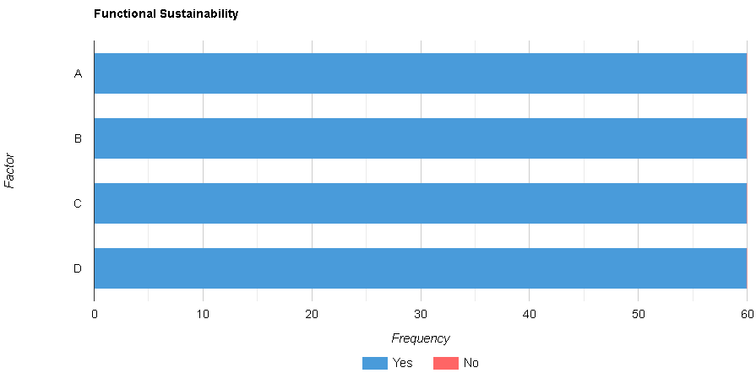

Graph 7. Factor: *Functional Sustainability*

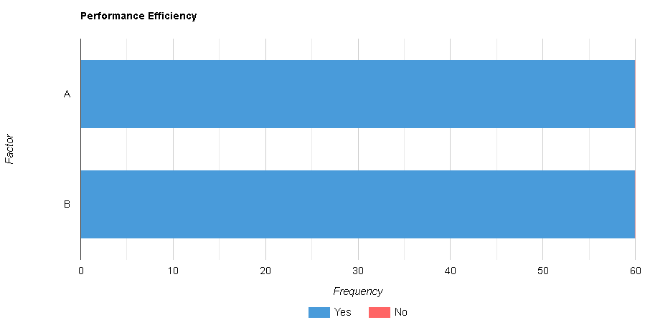

Graph 8. Factor: *Performance Efficiency*

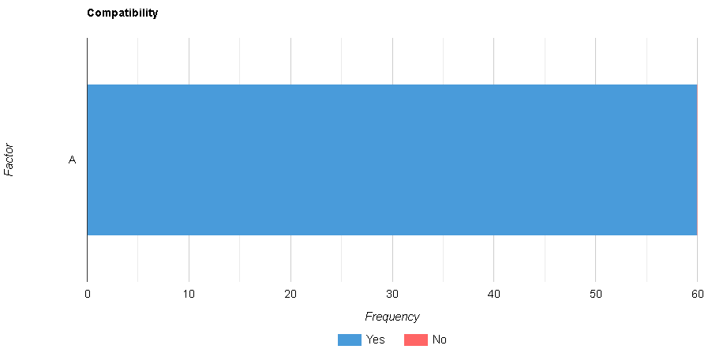

Graph 9. Factor: *Compatibility*

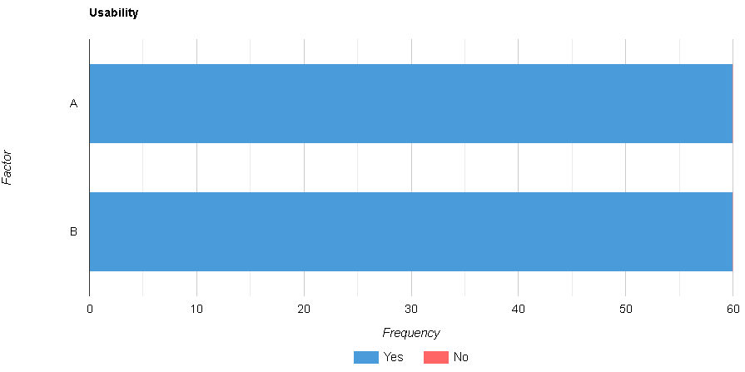

Graph 10. Factor: *Usability*

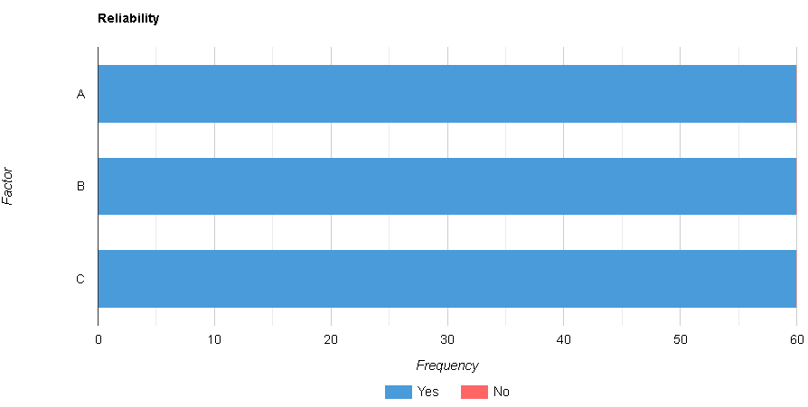

Graph 11. Factor: *Reliability*

Based on the table, a stacked bar chart has been created to represent the distribution of "Yes" and "No" responses for each factor. The chart illustrates the unanimous agreement among all 60 respondents for all factors. Each factor has a height of 100%, representing the full frequency of "Yes" responses and no "No" responses. The factors related to functional sustainability, including ease of navigation, providing up-to-date information, and delivering needed information about the school, all received unanimous support from all respondents, with 100% "Yes" responses and no "No" responses. Similarly, the factors associated with performance efficiency, such as regularly updated content and inclusion of useful information, received 100% agreement from all respondents, with no dissenting "No" responses. The compatibility factor, specifically compatibility with all types of operating systems, achieved unanimous support as well, with all respondents choosing "Yes" and no one selecting "No." For usability, both aspects—providing up-to-date information and offering legitimate information—were unanimously favored by all respondents, with 100% "Yes" responses and no "No" responses. Lastly, the factors related to reliability, including prevention of unauthorized access, ensuring a trusted path, and safeguarding user data, obtained unanimous agreement from all respondents, with no one indicating a "No" response.